Covering safer recruitment, safeguarding, data, protection and operational compliance in line with UK education standards
Effective from: January 2026
Reviewed annually or upon regulatory change
Aquinas Teacher RECRUITMENT LTD safegaurding & Compliance Pack
Education Recruitment
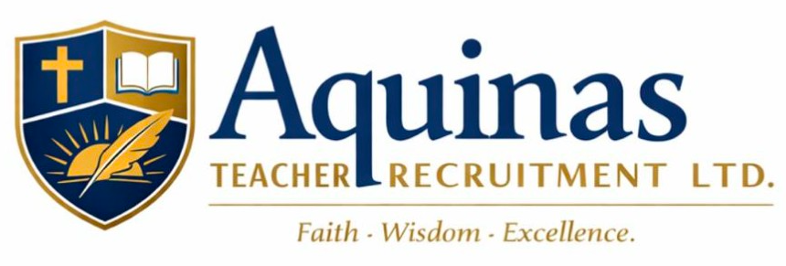
Key Contacts & Directors
Company: Aquinas Teacher Recruitment Ltd
Director & Primary Contact:
Paul O’Donoghue
Email: aquinasteacherrecruitment@gmail.com
Telephone: 07918 559574
Other Directors:
Nissanka John Ananda Fernando
Hayder Khan
Registered Office:
93 Cambray Road
Balham, London
SW12 0ER
ICO Registration Number: ZC074134
Companies House Number: 16936826
General Enquiries: aquinasteacherrecruitment@gmail.com

Aquinas Teacher Recruitment Ltd
Safeguarding & Compliance Pack
Contents (v1.0)
Section 1 – Company Information
- Company Overview
- Companies House Registration
- ICO Registration Confirmation

Section 2 – Safeguarding & Safer Recruitment
4. Safeguarding Policy
- Safer Recruitment Policy
- Allegations Management Procedure
- Prevent Duty Statement

Section 3 – Recruitment & Vetting Procedures
8. Recruitment Process Overview
- Identity & Right to Work Checks
- DBS (UK) & Garda Vetting (Ireland) Process
- Qualification & Reference Checks
- Overseas Police Checks (where applicable)

Section 4 – Data Protection & Information Security
13. Data Protection (GDPR) Policy
- Data Retention & Privacy Statement
- Secure Storage & Information Sharing

Section 5 – Operational & Legal
16. Terms of Business (Schools)
- Candidate Terms & Conditions
- Complaints Procedure
- Equal Opportunities & Diversity Policy

Section 6 – Insurance & Financial Protection
20. Professional Indemnity Insurance Certificate
- Public Liability Insurance Certificate
- Employer’s Liability Insurance Certificate

Section 7 – Declarations
23. Confirmation of Compliance
- Annual Review Statement

Section 1 – Company Information
1. Company Overview
Aquinas Teacher Recruitment Ltd is a UK-based education recruitment agency specialising in the placement of high-quality teaching professionals who have graduated from Irish universities into schools across London and the wider UK. The company focuses on sourcing newly qualified and experienced teachers, with a particular emphasis on recruiting from Ireland to support schools facing recruitment and retention challenges.
The company is led by experienced senior education professionals with extensive backgrounds in school leadership, safeguarding, behaviour, and pastoral systems. Aquinas Teacher Recruitment Ltd is committed to upholding the highest standards of safeguarding, safer recruitment, and compliance, in line with Keeping Children Safe in Education (KCSIE), GDPR, and UK employment legislation.
Aquinas Teacher Recruitment Ltd works collaboratively with schools to provide transparent, ethical, and compliant recruitment solutions. All candidates are subject to robust vetting and suitability checks prior to placement, and the company operates with a strong emphasis on safeguarding, professionalism, and long-term partnership with schools.
Aquinas Teacher Recruitment Ltd is also committed to supporting candidates throughout their placement in the UK. This includes assistance with sourcing accommodation and helping teachers integrate into the local community, including connecting them with local sports or cultural organisations such as the GAA where appropriate. This approach promotes wellbeing, professional stability, and long-term retention in schools.
Aquinas Teacher Recruitment Ltd does not employ or manage placed staff directly and does not assume responsibility for the supervision, direction, or control of individuals once placed within a school setting.

2. Companies House Registration
Company Name: Aquinas Teacher Recruitment Ltd
Companies House Number: 16936826
Company Type: Private Limited Company (Ltd)
Incorporation Date: 31st December 2025
Registered Office Address:
93 Cambray Road
Balham, London
SW12 0ER
Company Status: Active
Filing History: Up to date
Notes for Schools:
Aquinas Teacher Recruitment Ltd is fully registered with Companies House and complies with all UK company regulations. Verification of company registration can be done via the Companies House website: https://find-and-update.company-information.service.gov.uk/

3. ICO Registration Confirmation
Organisation Name: Aquinas Teacher Recruitment Ltd
ICO Registration Number: ZC074134
Date of Registration: 4th January 2026
Type of Organisation: Private Company Limited by Shares
Purpose of Registration: Processing personal data in the course of education recruitment, including staff and candidate information in line with GDPR requirements.
Data Protection Officer / Responsible Person: Paul O’Donoghue (Director & Primary Contact)
Notes for Schools:
Aquinas Teacher Recruitment Ltd is fully registered with the Information Commissioner’s Office (ICO) and complies with all UK data protection legislation (GDPR). Verification of registration can be done via the ICO website: https://ico.org.uk/

Section 2 – Safeguarding & Safer Recruitment
4. Safeguarding Policy
Aquinas Teacher Recruitment Ltd
1. Policy Statement
Aquinas Teacher Recruitment Ltd is committed to safeguarding and promoting the welfare of children and young people. We recognise our responsibility to ensure that all candidates we place in schools are suitable to work with children and that we operate in compliance with Keeping Children Safe in Education (KCSIE 2025), UK safeguarding legislation, and good practice guidance.
Our commitment extends to:
- Ensuring that children and young people are protected from harm while in the care of schools where we place staff.
- Maintaining robust safer recruitment procedures for all candidates.
- Supporting schools in fulfilling their safeguarding obligations by providing full and accurate information about candidates.

2. Scope
This policy applies to:
- All directors, staff, and associates of Aquinas Teacher Recruitment Ltd
- All candidates placed into schools via Aquinas Teacher Recruitment Ltd

3. Roles and Responsibilities
- Directors are ultimately responsible for ensuring compliance with safeguarding legislation and the implementation of this policy.
- Primary Contact (Paul O’Donoghue) serves as the point of contact for safeguarding matters and ensures that candidates and schools are aware of reporting procedures.
- Schools remain responsible for the supervision, direction, and safeguarding of placed staff once on their premises. Aquinas Teacher Recruitment Ltd does not supervise or manage staff directly in schools.

4. Safer Recruitment
Aquinas Teacher Recruitment Ltd will only supply candidates who have undergone:
- Full identity verification and right-to-work checks.
- Enhanced DBS checks (UK) and Garda Vetting (Ireland), where applicable.
- Qualification and reference checks.
- Overseas police checks where necessary.
We will ensure that all safeguarding documentation is verified, up-to-date, and recorded before placement.

5. Training & Awareness
While we do not directly manage staff in schools, we ensure that all candidates are aware of:
- School safeguarding procedures, including reporting concerns.
- The requirement to read and comply with school safeguarding policies.
- Their responsibilities to maintain professional conduct and protect children.

6. Supporting Candidate Wellbeing
To help candidates settle successfully and reduce safeguarding or wellbeing risks, Aquinas Teacher Recruitment Ltd offers guidance on:
- Finding suitable accommodation.
- Integrating into the local community, including connection with cultural or sporting organisations (e.g., local GAA clubs).
- Maintaining professional stability and long-term retention in schools.

7. Reporting Concerns
Any safeguarding concerns identified during the recruitment process or brought to our attention by a school will be:
- Logged and documented by the company.
- Immediately reported to the relevant school’s Designated Safeguarding Lead (DSL).
- Escalated to statutory agencies if required.
Note: Schools retain the primary responsibility for safeguarding staff and students once placed.

8. Policy Review
This policy will be reviewed annually or in line with changes to safeguarding legislation, KCSIE guidance, or best practice.
Effective from: January 2026
Next Review: January 2027 (or earlier if regulations change)

5. Safer Recruitment Policy
Aquinas Teacher Recruitment Ltd
1. Policy Statement
Aquinas Teacher Recruitment Ltd is committed to following best practice in safer recruitment to ensure that only suitable and qualified candidates are placed in schools. All recruitment activity is carried out in line with Keeping Children Safe in Education (KCSIE 2025), relevant employment legislation, and GDPR.
This policy applies to all candidates and staff involved in recruitment and placement.

2. Scope
- All candidates sourced and placed by Aquinas Teacher Recruitment Ltd.
- All directors and staff responsible for recruitment processes.
- All schools receiving candidates from Aquinas Teacher Recruitment Ltd.

3. Recruitment Principles
We will:
- Treat all candidates fairly, transparently, and consistently.
- Ensure the safeguarding and suitability of candidates before placement.
- Maintain accurate records of recruitment and vetting checks.
- Support schools with verified and compliant candidates.

4. Pre-Placement Checks
Prior to placing a candidate, Aquinas Teacher Recruitment Ltd will complete:
- Identity Verification
  - Passport, driving licence, or national ID check.
- Right to Work
  - UK and EU/Irish eligibility checks in line with Home Office guidance.
- Enhanced DBS Checks (UK)
  - Conducted in line with DBS regulations for all placements.
- Garda Vetting (Ireland)
  - Completed for all Irish candidates before placement.
- Qualifications and References
  - Verification of teaching qualifications.
  - Professional references from current or previous employers.
- Overseas Police Checks
  - Where candidates have lived outside the UK or Ireland, relevant police checks are obtained.
All documentation is verified and retained securely in compliance with GDPR.

5. Candidate Information
Candidates are provided with:
- Guidance on school safeguarding expectations.
- Awareness of their responsibilities under UK law and school policy.
- Support for wellbeing and integration into the local community (e.g., housing, cultural/sporting connections).

6. Schools’ Responsibilities
Once a candidate is placed:
- Schools retain responsibility for supervision, direction, and safeguarding.
- Aquinas Teacher Recruitment Ltd provides information and support but does not supervise placed staff.

7. Record Keeping
Aquinas Teacher Recruitment Ltd maintains:
- Verification records for each candidate.
- Copies of DBS/Garda Vetting/qualifications and references.
- A secure, GDPR-compliant storage system.
Records are available to schools or statutory authorities upon request.

8. Policy Review
This policy will be reviewed annually, or sooner if regulations or best practice guidance changes.
Effective from: January 2026
Next Review: January 2027

Section 2 – Safeguarding & Safer Recruitment
6. Allegations Management Procedure
Aquinas Teacher Recruitment Ltd
1. Purpose
This procedure outlines how Aquinas Teacher Recruitment Ltd will respond if an allegation or concern is raised about a candidate placed in a school. It ensures that all allegations are managed safely, promptly, and in accordance with statutory safeguarding guidance.

2. Scope
This procedure applies to:
- All candidates placed by Aquinas Teacher Recruitment Ltd
- All schools receiving candidates from the agency
- All directors and staff of Aquinas Teacher Recruitment Ltd

3. Reporting Allegations
- Any allegation made against a placed candidate must be reported immediately to the school’s Designated Safeguarding Lead (DSL).
- If a school contacts Aquinas Teacher Recruitment Ltd directly with an allegation, we will record the details and advise the school to follow their safeguarding policy.
- Allegations can relate to:
  - Abuse or harm to children
  - Breaches of professional conduct
  - Criminal behaviour

4. Agency Role
- Aquinas Teacher Recruitment Ltd will support the school by providing all verified documentation relevant to the candidate (DBS, Garda Vetting, references, qualifications).
- The agency does not supervise or manage the candidate once placed.
- We will maintain a record of the allegation and any steps taken for audit and compliance purposes.

5. Cooperation with Authorities
- Where allegations require referral to statutory agencies (e.g., local authority children’s services, police), Aquinas Teacher Recruitment Ltd will fully cooperate and provide relevant information.
- All actions will be recorded in a secure, GDPR-compliant manner.

6. Communication
- Schools are responsible for internal communications regarding the allegation.
- Aquinas Teacher Recruitment Ltd will only communicate with the school, the candidate, or statutory agencies as required and appropriate.

7. Record Keeping
- All allegations, actions taken, and outcomes are logged securely.
- Records are kept in compliance with GDPR and made available to schools or regulators if required.

7. Prevent Duty Statement
Aquinas Teacher Recruitment Ltd
1. Policy Statement
Aquinas Teacher Recruitment Ltd recognises its responsibilities under the Counter-Terrorism and Security Act 2015 (Prevent Duty). The company is committed to ensuring that all candidates we place in schools:
- Are aware of their responsibilities to safeguard children and young people from extremist views and behaviours.
- Will not engage in activities or behaviours that could encourage radicalisation or extremist ideology.

2. Scope
This statement applies to:
- All candidates sourced and placed by Aquinas Teacher Recruitment Ltd.
- All directors and staff involved in recruitment.
- All schools receiving candidates from our agency.

3. Responsibilities
- Aquinas Teacher Recruitment Ltd ensures that candidates are vetted, trained, and aware of safeguarding responsibilities before placement.
- Schools remain responsible for implementing the Prevent Duty within their premises, including monitoring and reporting concerns.
- Any concerns identified during recruitment or placement will be promptly reported to the school’s Designated Safeguarding Lead (DSL).

4. Record Keeping
- Records of all candidate checks and Prevent awareness confirmations are stored securely and available for audit.
- This supports schools in meeting their statutory obligations under the Prevent Duty.

Section 3 – Recruitment & Vetting Procedures
8. Recruitment Process Overview
Aquinas Teacher Recruitment Ltd
1. Candidate Sourcing
- Identify suitable candidates from Irish universities and other channels.
- Focus on newly qualified teachers (NQTs) and experienced teachers across subjects.

2. Initial Screening
- Review CVs and qualifications.
- Conduct a preliminary interview to assess suitability and motivation.
- Confirm the candidate’s eligibility to work in the UK.

3. Identity & Right to Work Checks
- Verify government-issued ID (passport, driving licence, or national ID).
- Confirm right to work in the UK (UK/EU/Irish checks).

4. Safeguarding & Background Checks
- Enhanced DBS check (UK)
- Garda Vetting (Ireland) for Irish candidates
- Overseas Police Checks where applicable
- Verification of professional references
- Qualification verification (teaching degree, PGDE, etc.)

5. Candidate Preparation & Induction
- Provide guidance on UK school expectations and safeguarding responsibilities.
- Offer support with accommodation and local community integration (e.g., connecting to local GAA or cultural organisations).
- Provide clear instructions for compliance with school policies and reporting procedures.

6. Placement & Ongoing Support
- Provide school with verified candidate profile and documentation.
- Candidate joins school; school retains responsibility for supervision, safeguarding, and daily management.
- Maintain regular contact to support wellbeing, integration, and retention.

7. Record Keeping
- Maintain secure, GDPR-compliant records for all candidates:
  - Identity documents
  - DBS/Garda Vetting certificates
  - Qualifications and references
- Records are available for school verification or statutory inspection as required.

8. Flow Summary (Visual)
Candidate sourced → CV & interview → ID & right to work checks →
DBS/Garda vetting & references → Qualifications verified →
Candidate induction → Placement in school → Ongoing support & record keeping

9. Identity & Right to Work Checks
Aquinas Teacher Recruitment Ltd
1. Policy Statement
Aquinas Teacher Recruitment Ltd ensures that all candidates are legally entitled to work in the UK and that their identity is verified prior to placement. This protects schools, children, and the agency from compliance and safeguarding risks.

2. Identity Verification
Before placement, candidates must provide official documentation to confirm their identity. Acceptable documents include:
- Passport (UK, Irish, or EU)
- National ID card
- Driving licence
All documentation is checked for authenticity and recorded securely in line with GDPR.

3. Right to Work Verification
- Confirm that candidates have the legal right to work in the UK, including Irish or EU citizens.
- Verification is carried out in accordance with Home Office guidance.
- Copies of documents are retained securely to support audit and school verification.

4. Record Keeping
- Identity and right to work checks are stored securely in GDPR-compliant systems.
- Verification records are available to schools or statutory authorities on request.

10. DBS (UK) & Garda Vetting (Ireland) Process
Aquinas Teacher Recruitment Ltd
1. Policy Statement
Aquinas Teacher Recruitment Ltd is committed to ensuring that all candidates are safe to work with children and young people. We conduct robust background checks through the Disclosure and Barring Service (DBS) in the UK and Garda Vetting in Ireland before any placement.

2. DBS (UK) Checks
- All candidates working in UK schools undergo an enhanced DBS check.
- Checks include:
  - Criminal record history
  - Barred lists (where applicable)
- Verification is conducted before candidate placement.
- Certificates are retained securely and shared with schools as required.

3. Garda Vetting (Ireland)
- For Irish candidates, Garda Vetting is obtained to ensure suitability to work with children.
- The vetting process includes:
  - Criminal record checks in Ireland
  - Confirmation of any relevant barring information
- Garda Vetting documentation is retained securely and provided to schools.

4. Overseas Police Checks (if applicable)
- Candidates who have lived outside the UK or Ireland are required to provide police clearance from their country of residence.
- This ensures that all candidates are appropriately vetted for safeguarding purposes.

5. Record Keeping & Compliance
- All checks are stored in secure, GDPR-compliant systems.
- Documentation is available to schools or statutory authorities on request.
- Vetting is refreshed as required to maintain compliance and candidate suitability.

11. Qualification & Reference Checks
Aquinas Teacher Recruitment Ltd
1. Policy Statement
Aquinas Teacher Recruitment Ltd ensures that all candidates are suitably qualified and professionally competent before placement in schools. This protects both the school and the students while supporting compliance with UK employment and education regulations.

2. Qualification Verification
- All candidates must provide proof of teaching qualifications, such as:
  - Bachelor’s or Master’s degree in Education or relevant subject
  - Postgraduate teaching qualifications (e.g., PGDE, Professional Diploma in Education)
- Qualifications are verified directly with the awarding institution where possible.
- Copies are stored securely in a GDPR-compliant system.

3. Reference Checks
- At least two professional references are obtained for each candidate.
- References must come from previous employers or educational institutions.
- Checks confirm:
  - Teaching experience and competency
  - Professional conduct and suitability to work with children
  - Attendance and reliability
- Reference details are documented and retained for audit purposes.

4. Compliance & Record Keeping
- Verification records are stored securely and confidentially.
- Records are available for inspection by schools or statutory authorities upon request.
- References and qualifications are reviewed prior to placement to ensure ongoing suitability.

12. Overseas Police Checks (Where Applicable)
Aquinas Teacher Recruitment Ltd
1. Policy Statement
Aquinas Teacher Recruitment Ltd is committed to ensuring that all candidates placed in schools are safe and suitable to work with children, including those who have lived outside the UK or Ireland. Where applicable, candidates must provide police clearance or equivalent documentation from countries in which they have resided.

2. Scope
- Candidates who have lived or worked outside the UK or Ireland for more than 6 months in the past 10 years.
- This check complements UK DBS and Irish Garda Vetting.

3. Procedure
- Candidates provide a police clearance certificate or official document from the country of residence.
- Aquinas Teacher Recruitment Ltd verifies the authenticity of the document where possible.
- Any issues or concerns are reviewed and escalated in line with safeguarding procedures.

4. Record Keeping
- All overseas police check documentation is stored securely in a GDPR-compliant system.
- Records are available for schools or statutory authorities upon request.
- Checks are retained for the duration of the placement and updated if a candidate moves countries.

Section 4 – Data Protection & Information Security
13. Data Protection (GDPR) Policy
Aquinas Teacher Recruitment Ltd
1. Policy Statement
Aquinas Teacher Recruitment Ltd is committed to protecting the privacy and security of all personal data collected from candidates, schools, and other stakeholders. This policy ensures compliance with the UK General Data Protection Regulation (UK GDPR) and the Data Protection Act 2018.

2. Scope
This policy applies to:
- All personal data collected, processed, and stored by Aquinas Teacher Recruitment Ltd
- Data relating to candidates, schools, suppliers, and staff
- All directors and staff responsible for handling personal data

3. Principles
Aquinas Teacher Recruitment Ltd ensures that all personal data is:
- Processed lawfully, fairly, and transparently
- Collected for specified, explicit purposes only
- Adequate, relevant, and limited to what is necessary
- Accurate and kept up-to-date
- Stored securely and protected against unauthorized access
- Retained only for as long as necessary and disposed of securely

4. Rights of Data Subjects
Individuals whose data we process have the right to:
- Access their personal data
- Request corrections to inaccurate data
- Request erasure where applicable
- Restrict processing of their data
- Object to processing for direct marketing purposes
- Lodge a complaint with the Information Commissioner’s Office (ICO)

5. Responsibilities
- Directors are responsible for ensuring compliance with this policy
- All staff handling data must follow GDPR principles and agency procedures
- Breaches or incidents must be reported immediately and managed in line with statutory requirements

6. Data Breach Management
- Any data breach will be recorded, investigated, and reported to the ICO where required
- Schools and individuals affected will be notified promptly

14. Data Retention & Privacy Statement
Aquinas Teacher Recruitment Ltd
1. Policy Statement
Aquinas Teacher Recruitment Ltd is committed to retaining personal data only for as long as necessary to meet statutory, regulatory, and business requirements. This ensures compliance with the UK GDPR and the Data Protection Act 2018, while protecting the privacy of candidates, schools, and other stakeholders.

2. Data Retention Periods
Record Type | Retention Period | Purpose
Candidate CVs & Applications | 12 months | Recruitment and placement purposes
Identity & Right to Work Documents | Duration of placement + 6 years | Employment compliance & audit
DBS / Garda Vetting Certificates | Duration of placement + 6 years | Safeguarding & compliance
Qualifications & References | Duration of placement + 6 years | Verification & audit
Placement Agreements / Contracts | Duration of placement + 6 years | Legal & financial record
Communications & Emails | 3 years | Reference & communication record
Complaints & Allegations Records | 6 years | Safeguarding & regulatory reporting
Note: Retention periods are regularly reviewed and may be extended if required by law or regulatory guidance.

3. Data Subject Rights
- Individuals can request access to their data, corrections, or erasure, where applicable.
- All requests are handled promptly and in line with GDPR procedures.

4. Secure Disposal
- Personal data that is no longer required is securely deleted or destroyed.
- Paper records are shredded, and digital files are permanently deleted using secure methods.

5. Responsibility
- Directors of Aquinas Teacher Recruitment Ltd are responsible for ensuring data retention compliance.
- All staff must follow procedures for secure storage and deletion of personal data.

15. Secure Storage & Information Sharing
Aquinas Teacher Recruitment Ltd
1. Policy Statement
Aquinas Teacher Recruitment Ltd is committed to maintaining the security and confidentiality of all personal and sensitive information. This ensures compliance with the UK GDPR, safeguarding requirements, and best practice in data management.

2. Secure Storage
- Digital Records:
  - Stored in password-protected, encrypted systems (e.g., Xero, secure cloud storage).
  - Access is limited to directors and authorised staff only.
- Paper Records:
  - Stored in locked filing cabinets or secure office space (where applicable).
  - Access is restricted to authorised personnel.
- Backups:
  - Digital records are backed up regularly and stored securely to prevent data loss.

3. Information Sharing
- Candidate information is only shared with schools, statutory authorities, or authorised parties when necessary for recruitment, safeguarding, or compliance purposes.
- Schools receive copies of relevant documents, such as:
  - DBS / Garda Vetting certificates
  - References and qualifications
  - Identity and right to work documentation
- Information is never shared with unauthorised third parties.

4. Staff Responsibilities
- All directors and staff must follow procedures for secure storage, controlled access, and safe sharing of data.
- Any suspected breach of data security must be reported immediately.

5. Compliance & Audit
- Records and processes are subject to regular review and audit to ensure ongoing compliance with GDPR and safeguarding regulations.
- Schools may request evidence of compliance for inspection or auditing purposes.

Section 5 – Operational & Legal
16. Terms of Business (Schools)
Aquinas Teacher Recruitment Ltd

1. Agency Fees

1.1 The standard Agency fee is 12% of the candidate’s first-year gross annual salary.

1.2 For hard-to-fill subjects or leadership positions, the Agency reserves the right to charge a higher fee of up to 15%, as agreed in writing with the School prior to the candidate’s acceptance of the offer.

---

2. Invoice Trigger & Payment Terms

2.1 The Agency fee becomes due once the School has made a formal offer of employment to the candidate and the candidate has accepted the offer. This event establishes the Agency’s right to invoice.

2.2 The invoice will be issued following the acceptance, and payment is due within 30 days of the candidate’s agreed start date, unless otherwise agreed in writing.

2.3 Late payment will incur interest at 4% above the Bank of England base rate per annum on any overdue amount.

2.4 Candidate Start Date / Delay: If the candidate’s start date is delayed, the invoice remains payable based on the originally agreed start date, unless otherwise agreed in writing.

2.5 Replacement / Refund Policy:

If the candidate ceases employment within 12 weeks of their start date:

Weeks 0–4: 100% replacement or full fee refund
Weeks 5–8: 50% replacement or partial refund
Weeks 9–12: 25% replacement or partial refund
The Agency must be notified in writing within 7 days of the candidate leaving for the replacement/refund to apply.
After 12 weeks, no replacement or refund is provided.

---

3. Candidate Ownership & Introduction Rights

3.1 Any candidate introduced to the School by the Agency is considered the Agency’s candidate for a period of 12 months from the date of introduction, regardless of whether the candidate is employed immediately.

3.2 If the School employs the candidate directly or indirectly, including via any third party, trust, or academy group, within the 12-month period, the Agency fee is payable in full.

3.3 The School agrees not to engage the candidate via any other recruitment agency, third party, or private arrangement to avoid paying the Agency fee. Any attempt to do so will still trigger the full Agency fee.

3.4 The School must notify the Agency in writing of any intention to offer employment to a candidate before making the offer. Failure to notify does not negate the Agency’s entitlement to fees.

3.5 The Agency retains the right to require evidence of any employment offer made to a candidate introduced by the Agency and may seek legal remedies for recovery of fees if necessary.

---

4. Data Protection & Candidate Confidentiality

4.1 The Agency will provide candidate information, including CVs, references, qualifications, and interview notes (together, “Candidate Data”), to the School solely for the purpose of evaluating potential employment. The School may retain Candidate Data for a period of 12 months from the date of receipt.

4.2 The School agrees not to share Candidate Data with any third party without the Agency’s prior written consent.

4.3 Both parties agree to comply with the UK GDPR and the Data Protection Act 2018. The Agency is registered with the Information Commissioner’s Office (ICO) and has implemented appropriate measures to protect Candidate Data.

4.4 Any unauthorized use, disclosure, or retention of Candidate Data beyond the permitted period may result in the Agency seeking legal remedies, including recovery of fees and damages.

---

5. School Obligations

5.1 Safeguarding & DBS / Vetting: The School is solely responsible for ensuring all safeguarding checks, including DBS / Protecting Vulnerable Groups checks, are completed prior to employment. The Agency may assist in processing or coordinating these checks, but the ultimate legal responsibility remains with the School.

5.2 Information Accuracy: The School must provide accurate information regarding the role, salary, start date, contract type, and any other relevant employment conditions. The School must notify the Agency immediately of any material changes.

5.3 Compliance with Laws: The School must comply with all applicable UK employment legislation, including equality, safeguarding, health & safety, and right-to-work requirements.

---

6. Governing Law & Miscellaneous

6.1 Governing Law: These Terms of Business are governed by and shall be construed in accordance with the laws of England & Wales, with the courts of England & Wales having exclusive jurisdiction.

6.2 Entire Agreement: These Terms constitute the entire agreement between the Agency and the School regarding recruitment services and supersede all prior agreements or representations.

6.3 Amendments: Any amendments must be agreed in writing by both parties.

6.4 Severability: If any provision is found invalid or unenforceable, the remaining provisions continue in full force.

6.5 Waiver: No failure or delay by the Agency in exercising any right under these Terms shall operate as a waiver of that right.

6.6 Notices: Notices shall be given in writing via email or post. Notices are deemed received 24 hours after email or 3 days after post.

6.7 Force Majeure: The Agency shall not be liable for failure or delay due to circumstances beyond its reasonable control, including acts of God, government action, industrial disputes, or technical failures
---

7. Acceptance & Signature

By signing below, the School confirms that it has read, understood, and agrees to these Terms of Business.

School Name
Signature
Name (Print)
Position
Date

17. Candidate Terms & Conditions
Aquinas Teacher Recruitment Ltd
1. Scope
These Terms & Conditions apply to all candidates placed or introduced by Aquinas Teacher Recruitment Ltd into schools in the UK.

2. Engagement
- Candidates are engaged by the school, not the Agency.
- The Agency does not supervise, direct, or manage candidates once placed.

3. Compliance & Conduct
Candidates must:
- Comply with all school policies, including safeguarding, behaviour, and professional standards.
- Adhere to UK employment law and statutory obligations.
- Act in a professional and ethical manner at all times.

4. Documentation
Candidates must provide:
- Verified qualifications and references
- DBS / Garda Vetting certificates
- Identity and right to work documentation
Failure to provide accurate documents may invalidate placement.

5. Health & Safety
- Candidates are responsible for following all school health and safety procedures.
- Any health or safety concerns must be reported immediately to the school.

6. Confidentiality
- Candidates must maintain confidentiality of school information, pupils, and colleagues.
- Breach of confidentiality may result in termination of placement.

7. Data Protection
- Candidates’ personal data will be processed securely in accordance with UK GDPR.
- Information is only shared with schools for recruitment and placement purposes.

8. Support & Guidance
- The Agency provides candidates with guidance on settling into the school and local community, including:
  - Finding accommodation
  - Local support networks (e.g., Irish GAA clubs)
  - Professional and pastoral support

18. Complaints Procedure
Aquinas Teacher Recruitment Ltd
1. Policy Statement
Aquinas Teacher Recruitment Ltd is committed to providing a professional, transparent, and responsive service. This procedure ensures that any complaints from schools, candidates, or other stakeholders are handled fairly, promptly, and effectively.

2. Scope
This procedure applies to:
- Schools receiving candidates from Aquinas Teacher Recruitment Ltd
- Candidates placed or introduced by the Agency
- Any other stakeholders involved in the recruitment process

3. How to Raise a Complaint
- Initial Contact:
  - Complaints should be submitted in writing to the Agency’s primary contact:
    - Email: aquinasteacherrecruitment@gmail.com
    - Phone: 07918 559574
- Details Required:
  - Nature of the complaint
  - Date, time, and location of the incident (if applicable)
  - Names of any parties involved
  - Supporting evidence or documentation

4. Investigation Process
- The Agency will acknowledge receipt of the complaint within 3 working days.
- An investigation will be carried out by one or more directors to review all relevant evidence.
- The Agency may contact the complainant, candidate, or school for further information.
- A formal response will be provided within 15 working days.

5. Resolution & Follow-Up
- Where a complaint is upheld, the Agency will implement appropriate corrective actions.
- Outcomes will be communicated clearly, including any changes to processes, procedures, or future placements.
- Complaints are recorded and reviewed for continuous improvement.

6. Escalation
- If the complainant is not satisfied with the response, they may escalate the matter to regulatory bodies or statutory authorities, where appropriate.

19. Equal Opportunities & Diversity Policy
Aquinas Teacher Recruitment Ltd
1. Policy Statement
Aquinas Teacher Recruitment Ltd is committed to promoting equal opportunities and fostering diversity and inclusion in all aspects of recruitment, placement, and business operations. The Agency ensures that all candidates and schools are treated fairly, without discrimination, in line with the Equality Act 2010.

2. Scope
This policy applies to:
- All candidates applying for roles through the Agency
- All schools engaging with the Agency
- Directors, staff, and contractors involved in recruitment activities

3. Principles
- No Discrimination: Recruitment decisions are based solely on skills, qualifications, and experience, not on age, race, gender, religion, sexual orientation, disability, or any protected characteristic.
- Inclusive Practices: The Agency actively promotes inclusive recruitment practices and reasonable adjustments for candidates where required.
- Harassment & Bullying: Harassment, bullying, or victimisation of any kind will not be tolerated.

4. Recruitment & Placement
- Job opportunities are advertised openly and fairly.
- Shortlisting, interviews, and placements are based on merit and suitability for the role.
- Schools are provided with candidates vetted without bias.

5. Monitoring & Review
- The Agency monitors recruitment practices to ensure compliance with equality and diversity standards.This policy is reviewed annually or upon regulatory change to maintain best practice.
Section 6 – Insurance & Financial Protection
20. Professional Indemnity Insurance Certificate
Aquinas Teacher Recruitment Ltd
1. Purpose
Professional Indemnity (PI) Insurance provides financial protection for Aquinas Teacher Recruitment Ltd against claims arising from negligence, errors, or omissions in the recruitment services we provide to schools.

2. Scope of Cover
- Covers claims from schools or clients resulting from professional advice, recruitment processes, or placement errors.
- Provides protection up to £1,000,000 per claim.
- Includes legal costs associated with defending claims.

3. Certificate Details
- Insurer: Hiscox Insurance Company Ltd
- Policy Number: 15579827
- Period of Cover: 10/01/2026 to 09/01/2027
- Coverage Limit: £1,000,000
- Signatory: Policy issued via PolicyBee on behalf of Hiscox Insurance Company Ltd

4. Record Keeping
- A copy of the certificate is retained in the compliance pack.
- Schools may request a copy for audit or verification purposes.

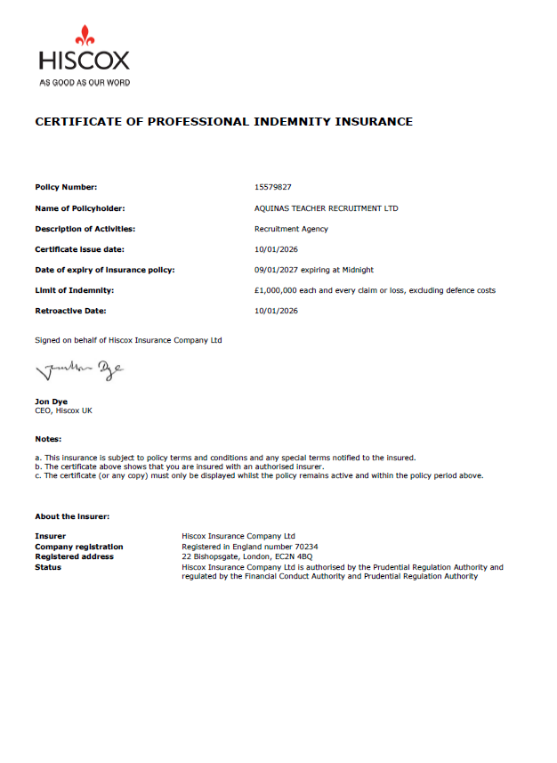

21. Public Liability Insurance Certificate
Aquinas Teacher Recruitment Ltd
1. Purpose
Public Liability (PL) Insurance provides protection for Aquinas Teacher Recruitment Ltd against claims arising from injury or property damage to third parties caused by the Agency’s activities.

2. Scope of Cover
- Covers claims from schools, candidates, or other third parties for:
  - Bodily injury
  - Property damage
  - Accidental loss arising from business activities
- Provides protection up to £1,000,000 per claim.
- Includes legal costs associated with defending claims.

3. Certificate Details
- Insurer: Hiscox Insurance Company Ltd
- Policy Number: 15579827
- Period of Cover: 10/01/2026 to 09/01/2027
- Coverage Limit: £1,000,000
- Signatory: Policy issued via PolicyBee on behalf of Hiscox Insurance Company Ltd

4. Record Keeping
- A copy of the certificate is retained in the compliance pack.
- Schools may request a copy for verification or auditing purposes.

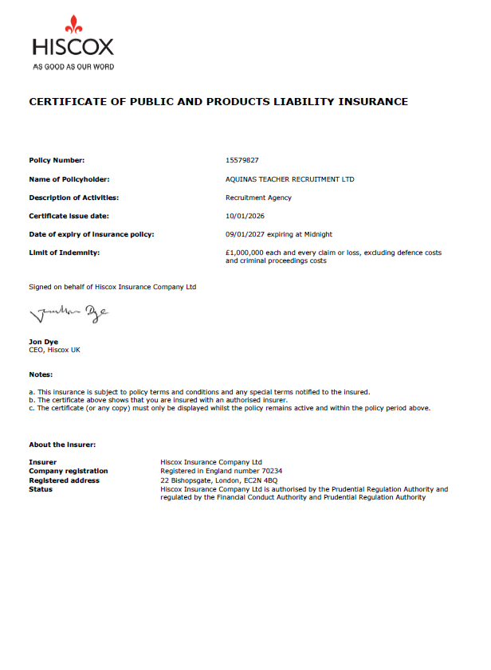

22. Employer’s Liability Insurance Certificate
Aquinas Teacher Recruitment Ltd
1. Purpose
Employer’s Liability (EL) Insurance provides protection for Aquinas Teacher Recruitment Ltd against claims by employees for injury, illness, or loss arising from their work with the Agency. This insurance is a legal requirement in the UK for businesses with employees.

2. Scope of Cover
- Covers claims made by employees, including directors, for:
  - Accidental injury at work
  - Occupational illness
  - Loss arising from negligence of the employer
- Provides protection up to £10,000,000 per claim.
- Includes legal costs associated with defending claims.

3. Certificate Details
- Insurer: Hiscox Insurance Company Ltd
- Policy Number: 15579827
- Period of Cover: 10/01/2026 to 09/01/2027
- Coverage Limit: £10,000,000
- Signatory: Policy issued via PolicyBee on behalf of Hiscox Insurance Company Ltd

4. Record Keeping
- A copy of the certificate is retained in the compliance pack.
- Schools or statutory authorities may request a copy for audit or compliance purposes.

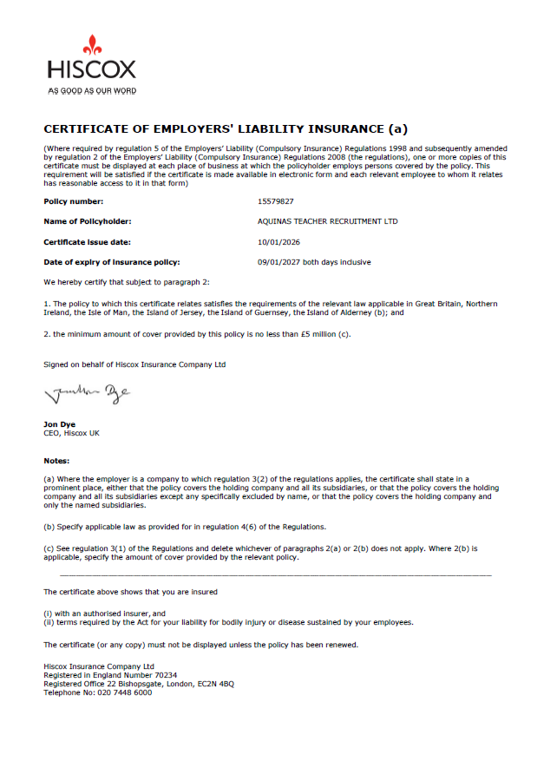

Section 7 – Declarations
23. Confirmation of Compliance
Aquinas Teacher Recruitment Ltd
1. Statement
Aquinas Teacher Recruitment Ltd confirms that, to the best of its knowledge and belief, all business operations, recruitment procedures, and placements are conducted in full compliance with:
- Keeping Children Safe in Education (KCSIE)
- UK GDPR / Data Protection Act 2018
- Safeguarding and safer recruitment legislation
- Equality Act 2010 and non-discrimination requirements
- Employment law and statutory obligations

2. Safeguarding & Recruitment Compliance
- All candidates are subject to robust vetting, reference checks, qualification verification, and DBS / Garda vetting prior to placement.
- The Agency does not supervise or manage candidates once placed but provides guidance and support to ensure successful integration.
- Policies and procedures are reviewed and updated regularly to reflect changes in legislation and best practice.

3. Director Declaration
We, the undersigned directors of Aquinas Teacher Recruitment Ltd, confirm that this Compliance Pack accurately reflects our policies, procedures, and practices and that we are committed to maintaining high standards of safeguarding, professional conduct, and legal compliance.
Effective From: January 2026
Reviewed: Annually or upon regulatory change
Directors:
- Paul O’Donoghue – Primary Contact
- Nissanka John Ananda Fernando
- Hayder Khan
Signed: ________________________ Date: _______________
24. Annual Review Statement
Aquinas Teacher Recruitment Ltd
Policy Review
All policies, procedures, and documentation contained in this Compliance Pack are reviewed at least once every 12 months, or sooner if there are changes in legislation, statutory guidance, or best practice.
Responsibility
- The directors of Aquinas Teacher Recruitment Ltd are responsible for ensuring timely review and updates.
- Any changes are documented, dated, and communicated to relevant stakeholders as required.
Purpose
- To maintain compliance with safeguarding, employment, and data protection regulations
- To ensure schools and candidates have the most current policies
- To demonstrate a commitment to continuous improvement and professional standards
Effective From: January 2026
Next Scheduled Review: January 2027
Signed: ________________________ Date: _______________
Directors: Paul O’Donoghue, Nissanka John Ananda Fernando, Hayder Khan

