

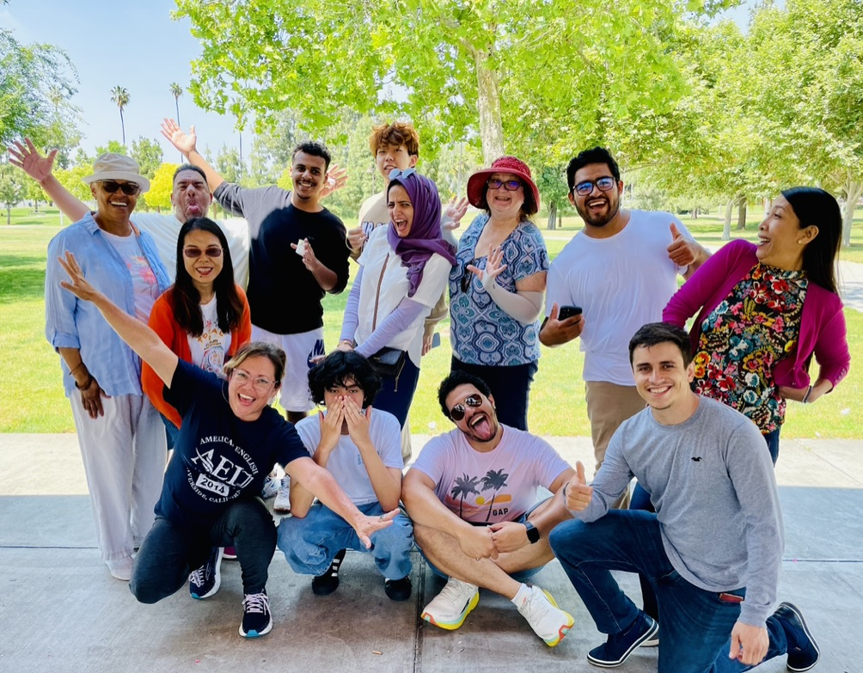
AEI SCHOOL CATALOG 2026
EFFECTIVE 1/1/2026 -12/31/2026
REVISED: 1/28/2026

Table of Contents
Approval Disclosure Statement......................................................................................4
Accreditation and Affiliations........................................................................................5
School Performance Fact Sheet......................................................................................6
Director’s Welcome....................................................................................................7
About Us..................................................................................................................8
AEI’s Staff & Teachers.................................................................................................9
Program Dates and Fees ............................................................................................ 10
Programs .............................................................................................................. 11
Directory of Whom to Contact..................................................................................... 13
Academic Policies .................................................................................................... 14
Absence Policy................................................................................................................................
Classroom Expectations.....................................................................................................................
Homework.....................................................................................................................................
Use of Electronic Devices...................................................................................................................
In Danger of Failing Notice .................................................................................................................
Student Complaints..........................................................................................................................
Cheating.......................................................................................................................................
Change of Address ...........................................................................................................................
Notice to Withdraw..........................................................................................................................
Academic Probation .........................................................................................................................
Change of Level Request Policy............................................................................................................
Admission Requirements....................................................................................................................
Placement into AEI Levels ..................................................................................................................
Credits Earned at Other Institutes ........................................................................................................
Credit for Experiential Learning...........................................................................................................
English Assessment...........................................................................................................................
Language of Instruction .....................................................................................................................
Federal or State Financial Aid .............................................................................................................
Loans...........................................................................................................................................
Placement Service ...........................................................................................................................
Immigration, Vacation, And Temporary Absences............................................................. 18
Student Services...................................................................................................... 20
Housing ........................................................................................................................................
Homestay with a Family ....................................................................................................................
High School Placement......................................................................................................................
College & University Placement Service..................................................................................................
Airport Pick-Up Service .....................................................................................................................
Transportation In and Around Riverside......................................................................... 22
Banks and Money Transactions in the U.S........................................................................23
Health Insurance Policy............................................................................................. 24
Health Care in the USA......................................................................................................................
AEI’s Health Insurance Policy ..............................................................................................................
Urgent Care ...................................................................................................................................
Local Medical Facilities ............................................................................................. 25
Emergency Facilities.........................................................................................................................
Pharmacy & Clinic Services.................................................................................................................
Safety .................................................................................................................. 26
Emergencies ..................................................................................................................................
Non Emergencies.............................................................................................................................
Important Safety Tips .......................................................................................................................
Door Locks and Window Locks .............................................................................................................
Child Safety Tips .............................................................................................................................
While at Home................................................................................................................................
If a Burglar Tries to Enter Your Home ....................................................................................................
Neighborhood Safety Tips...................................................................................................................
Earthquake Safety and Preparation .......................................................................................................
Cancellation Agreement ............................................................................................ 28
Bureau for Private Postsecondary Education................................................................... 29
Student Tuition Recovery Fund Disclosures .............................................................................................
Notice Concerning Transferability of Credits and Credentials Earned at Our Institution ........................................
Contacting BPPE..............................................................................................................................
Canyon Crest Towne Centre ....................................................................................... 32
Attractions in Southern California................................................................................. 35

American English Institute Information

2002 Iowa Ave #110
Riverside CA 92507 U.S.A.

Telephone: 951-824-6150
Email: info@american-english-insitute.com
Website: http://www.american-english-institute.com

DISCLAIMER:
Although we have included information on local businesses in this handbook, we do not endorse or favor any of the sample businesses or companies listed, nor do we take any responsibility for a student’s individual experiences with such companies. The purpose of listing such names and numbers is only to provide the student with a sample. It is the student’s responsibility to decide what best suits his/her needs. We welcome suggestions and comments.

APPROVAL DISCLOSURE STATEMENT

American English Institute (AEI) is a private institution that is approved to operate by the State of
California Bureau for Private Postsecondary Education (BPPE). Approval to operate means compliance with the standards as set forth in the CEC and 5, CCR. AEI is institutionally accredited by the Commission on English Language Program Accreditation (CEA).

We are approved to offer the following courses:

Intensive English (5 ESL Levels) – 20 hours per week
Class Schedule: 10am - 2:40pm Tuesday-Friday
Classes held at: 2002 Iowa Ave #110, Riverside, CA 92507
Each 50 minute class is considered one hour of class time.

Instruction at the institute is comprised of 5 classrooms that accommodate approximately five to sixteen students per classroom at any one time.

As a prospective student, you are encouraged to review this catalog prior to signing an enrollment agreement. You are also encouraged to review the School Performance Fact Sheet, which must be provided to you prior to signing an enrollment agreement.

The institution, the facility it occupies, and the equipment it utilizes fully comply with any and all federal, state, and local ordinances and regulations, including those requirements as to fire safety, building safety, and health codes.

The institute does not have any pending petition in bankruptcy, is not operating as a debtor in possession, has not filed a petition within the preceding five years, and has not had a petition in bankruptcy filed against it within the preceding five years that resulted in reorganization under Chapter 11 of the United States Bankruptcy Code (11 U.S.C. Sec 1101 et seq.).

ACCREDITATION AND AFFILIATIONS

American English Institute is authorized under federal law to enroll non-immigrant alien students.

AEI is a private institution and is approved to operate by the State of California Bureau for Private Postsecondary Education (BPPE). Approval to operate means compliance with standards as was set forth in the CEC and 5, CCR.


The American English Institute is accredited by the Commission on English Language Program Accreditation for the period April 2021 through April 2031 and agrees to uphold the CEA Standards for English Language Programs and Institutions. CEA is recognized by the U.S. Secretary of Education as a nationally recognized accrediting agency for English language programs and institutions in the U.S. For further information about this accreditation, please contact CEA, 1001 N. Fairfax Street, Suite 630, Alexandria, VA 22314, (703) 665-3400, www.cea-accredit.org.
We are also a proud member of NAFSA. NAFSA is the Association of International Educators is the world's largest nonprofit association dedicated to international education and exchange. NAFSA serves the needs of more than 10,000 members and international educators worldwide at more than 3,500 institutions, in more than 160 countries.

SCHOOL PERFORMANCE FACT SHEET

2022-2023
American English Institute offers an Intensive English Program to International Students. The credits earned at AEI are NOT transferable to any other institution. In addition students attending Intensive English Programs are NOT authorized to work in the United States. Also, students are NOT eligible for government student loans or grants.

- Completion Rate: Main Campus

Calendar Year | Number of Students Who Began Program | Students Available for Graduation | Number of On-Time Graduates | On-Time Completion Rate
2022 | 74 | 49 | 38 | 78.7%
2023 | 34 | 34 | 27 | 79%

- Placement Rates: No students are placed in employment.
- License examination passage rates: N/A
- Wage & Salary Information: N/A
- This Program does NOT lead to employment.
- This Fact Sheet is filed with the Bureau for Private Post Secondary Education.

“Regardless of any information you may have relating to Completion rates, placement rates, passage rates, starting salaries or license exam. This Fact Sheet contains the information as calculated pursuant to the law.”

- Any questions a student may have regarding this fact sheet that have not been satisfactorily answered by the institution may be directed to:

Bureau of Private Postsecondary Education
Physical Address: 1747 N. Market Blvd. #225, Sacramento, CA 95834
Mailing Address: P.O. Box 980818, West Sacramento, CA 95798-0818
P: (916) 574-8900 Toll Free: (888)370 -7589
F: (916) 263-1897
www.bppe.ca.gov

DIRECTOR’S WELCOME MESSAGE

Dear Student,

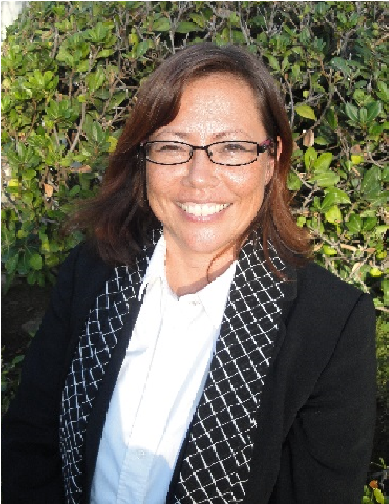
Welcome to American English Institute! We understand that studying English is a journey to achieve your goals and dreams—whether educational, professional, or personal. American English Institute will help you every step of the way! Our programs are designed to inspire you to improve your English in a comfortable and friendly environment. Our programs are dynamic and innovative to make learning fun and engaging. And, our location in Southern California also provides ideal weather and attractions for exploration and adventure outside of class!

As the director, I have over twenty years of experience helping thousands of students to achieve their academic, professional and personal objectives. We are here to help you, and we are a student-centered program. If there is something you want to learn. Let us know! We will work to incorporate it into our programs and classes.

Our classes are academic in nature. You will have homework, quizzes, tests, midterms and finals. That sounds very serious, but we hope that students understand that tests are guideposts to help you learn more effectively. Your attendance is important. If you miss just one day, it is over 4 hours of instruction missed. So I encourage you to have perfect attendance for maximum learning and progress!

We also want you to enjoy your studies, make friends with our students from around the world, and explore all that Riverside and Southern California have to offer. Thank you for joining us and have a great session!

Kindly,

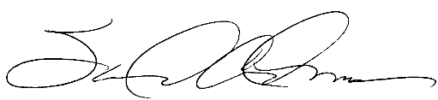

Sandra Adams
Director
American English Institute

ABOUT US
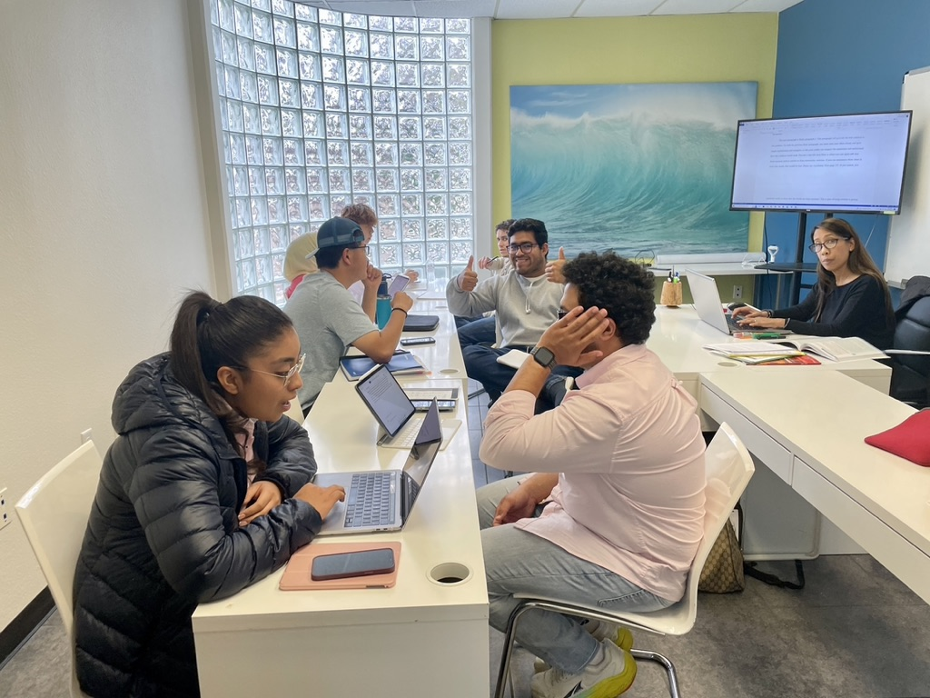
American English Institute is an intensive English and test preparation center. We offer a variety of English programs as well as test preparation tutoring in IELTS, TOEFL, GRE, and GMAT. In addition, we place students in high schools, colleges, and university through our partnerships with schools in the area. We also offer vacation programs for youth during winter and summer months.
Our student services include homestay placement, activities so students can explore Southern California, college counseling, and airport pick-up. We are committed to helping students communicate in English with confidence and to having an enjoyable stay during their studies.

Our Mission
Our mission is to help students to improve their English for admission to and success at U.S. high schools, colleges, and universities, and to help non-native speakers improve their English for personal growth and professional advancement.

American English Institute’s Value:
- Superior quality English instruction
- Innovative teaching methods with dynamic instructors and friendly staff
- Intensive one-on-one test preparation tutoring in TOEFL, IELTS, GMAT, and GRE specifically designed for international students
- Learning opportunities with American students through presentations, projects, and community engagement • Integration in the community through service learning and extracurricular activities

AEI’S STAFF AND TEACHERS

Sandra Adams Director
Sandra graduated from the University of California, Irvine where she received her BA in English Literature. She received her Master of Science in Leadership and Management from the University of La Verne. She enjoys hiking, developing new programs, and meeting and exceeding student expectations.

Chenhsin Huang
Student Services Coordinator
Chenhsin is currently studying with a bachelor’s degree in psychology from the University of California, Riverside. After UCR, he hopes to complete a second degree in Mechanical Engineering at NCKU in Taiwan.

INSTRUCTORS

American English Institute employs instructors that hold a minimum of a Bachelor's Degree from an accredited university or college, and most of our instructors also hold master’s degrees. In addition, they have extensive experience in teaching English as a Second Language (ESL).

AEI instructors provide both a rigorous and enjoyable learning environment for students using a communicative method. So, while students are learning reading, they will also have many opportunities to speak in class. AEI’s small classes have on average 5-8 students so instructors are able to provide students with individual attention. Our instructors are committed to providing the best possible learning experience for our students.

Stephen Burns

ESL Instructor / Special Projects Coordinator
Steve has master’s degrees in both applied linguistics/second language instruction and theology, and has been teaching in ESL/EFL capacities for nearly 20 years. He has traveled extensively and lived and taught internationally as well as studied a variety of languages and cultures. In his free time, Steve enjoys cooking, helping his wife homeschool their five children and working with youth in faith-based outreach.

Nicole Holle

ESL Instructor
Nicole received her B.A. in English from the University of Redlands and her M.A. in English from San Francisco State university. Also she attended an MFA program at UC Riverside. She has taught for more than 15 years at both of public and private schools. She also is a lecturer at several community colleges and universities. She is an accomplished writer and has had several short stories published in journals and literary magazines. She enjoys reading, Amazon T.V., hanging out with her dog Rosie and interacting with students from all over the world.

Holly Wrangell

ESL Instructor
Holly graduated from the University of Minnesota with a B.A. in Philosophy. She has taught English at UC Riverside Extension and also received her TEFL Certificate from UC Riverside Extension. She also designs and sells her own jewelry line.
Holly is fascinated by different cultures and languages. She loves international foods. An avid gardener, she loves growing exotic fruits and vegetables.

2026 PROGRAM DATES & FEES

Registration
New F-1 students are required to report to school within 7 days of arrival to the United States or upon successful transfer to American English Institute. Please be prepared to pay all outstanding fees related to your program, and student services.

2026

SESSION 1:
January 6 – February 27
SESSION 2:
March 9 – May 1
SESSION 3:
May 11 – July 3
SESSION 4:
July 7 – August 28
SESSION 5:
September 7 – October 16 (6weeks) (0930h-1500h)
SESSION 6:
October 26 – December 18

4-Week Session Dates

SESSION 1:
1A: January 6 – January 30
1B: February 4 – February 27
SESSION 2:
2A: March 9 – April 3
2B: April 7 – May 1
SESSION 3:
3A: May 11 – June 5
3B: June 9 – July 3
SESSION 4:
4A: July 7 – July 31
4B: August 4 – August 28
SESSION 5:
5A: September 7 – September 25 (3 week) (9:30am – 3:00pm)
5B: September 27 – October 16 (3 week) (9:30am – 3:00pm)
SESSION 6:
6A: October 26 – November 20
6B: November 24 – December 18
Fees
Application Fee Non Refundable: | $125
STRF Non Refundable Fee: | $0 per $1000 institutional charges
Tuition: | $3395 for 8-weeks $2395 for 4-weeks
Student Services: | $110 for 8-weeks $60 for 4-weeks
Books and Materials: | $varies by session approximate cost
Total and Estimated Charges for Period of Attendance: $3630 initial 8-Week Session Total without books and Estimated Charges for the Entire Educational Period: $17650 for a 12-month period.

Subsequent 8-Week Sessions: $3630 without books due on or before the start date of each session

Optional Fees
o | Airport Pickup (LAX): | $varies
o | Health Insurance: | $175/ 4-weeks
o | Homestay Placement: | $150
o | Homestay: | $1400/month (without transportation)
o | Homestay: | $1500/month (with transportation to/from school)

Optional Fees
o TOEFL/IELTS/GRE/GMAT Test Prep Tutoring: $75/hr
o General English Tutoring (1-on-1): $50/hr

PROGRAMS
4-WEEK AND 8-WEEK INTENSIVE ENGLISH PROGRAM
The Intensive English Program helps students to improve their English quickly to succeed in a U.S. academic setting as well as in daily life and work.

AEI’S LEVELS:
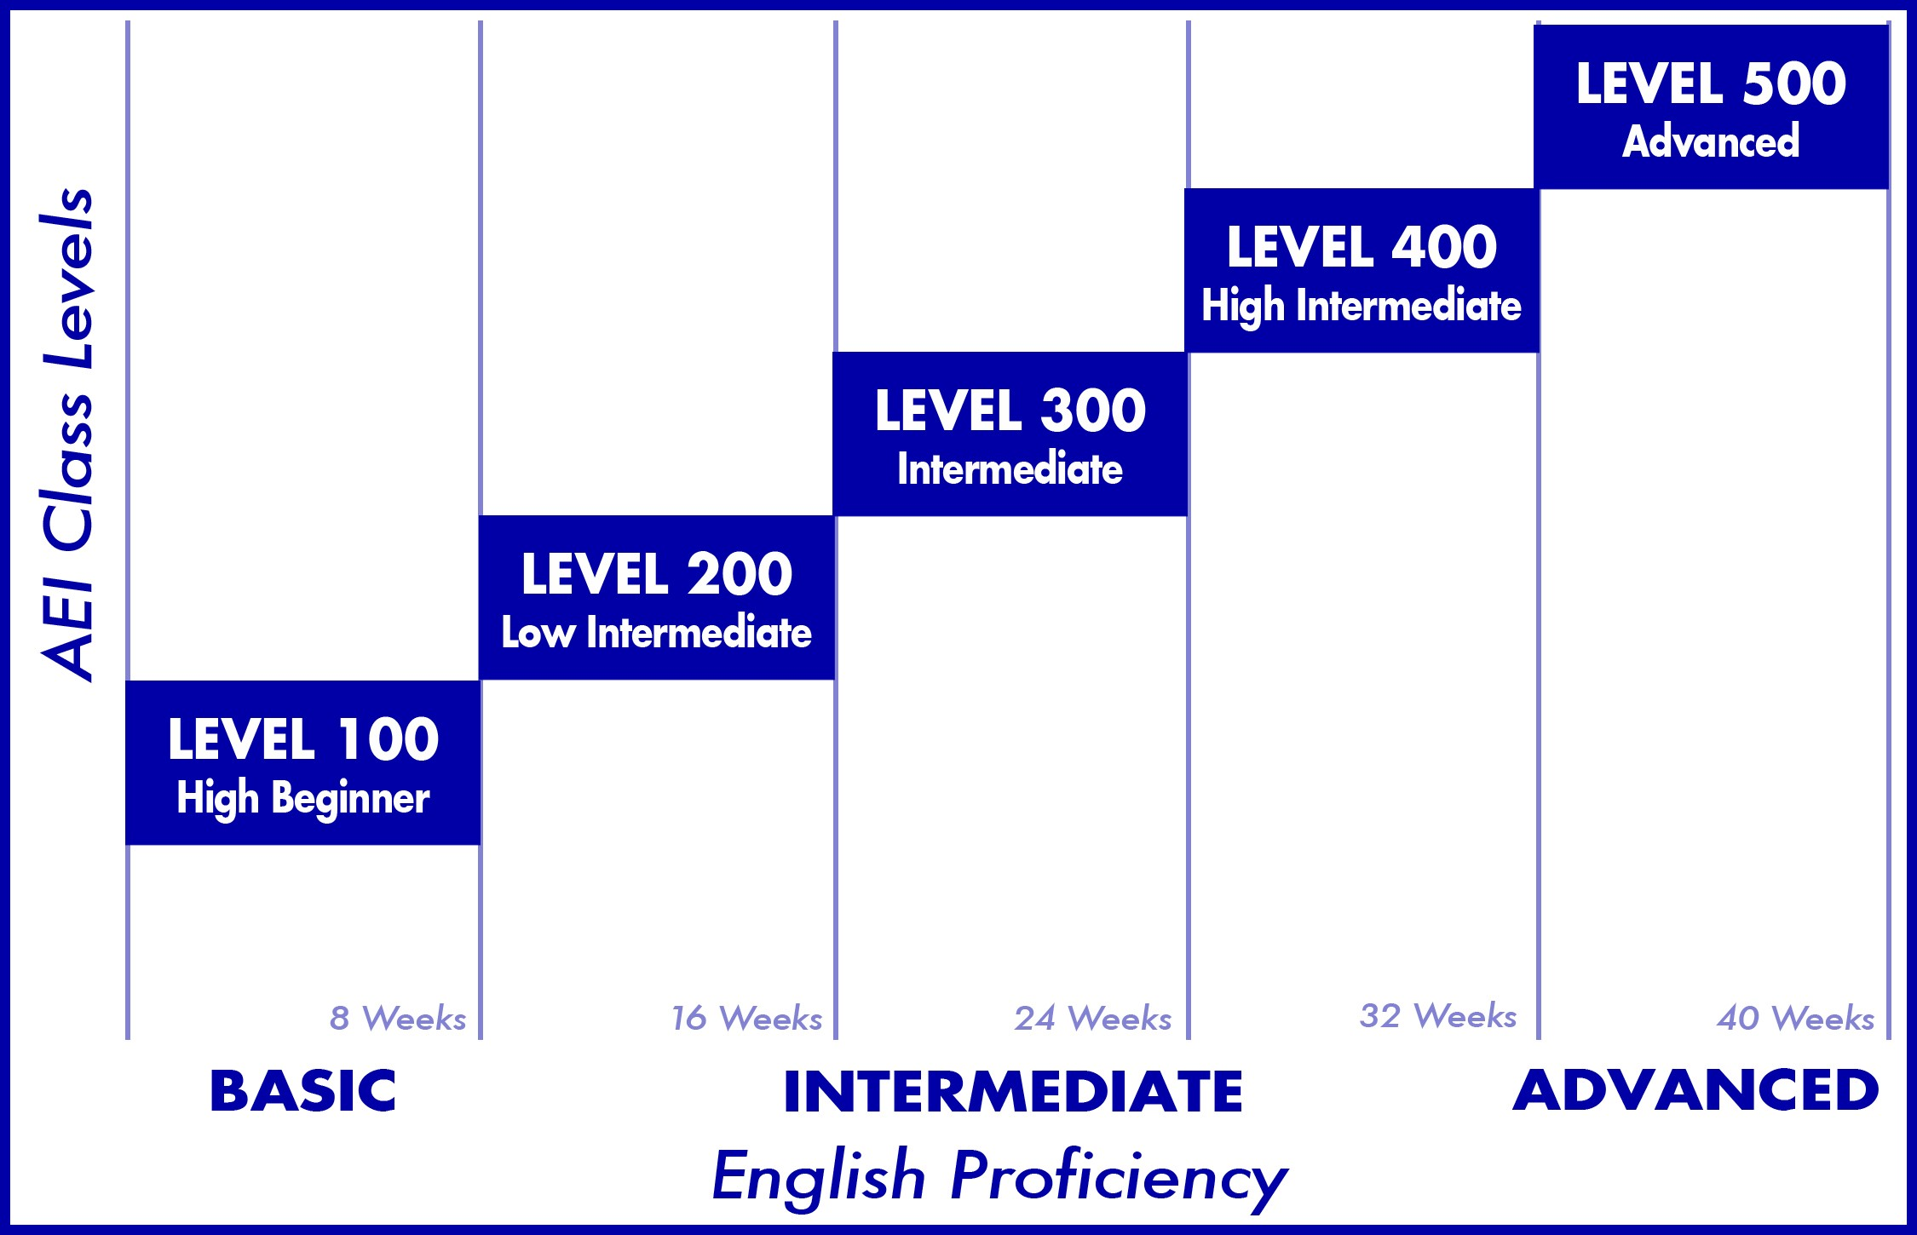

Each 4 and 8-week session includes:
- 5 levels of English from high beginner to advanced
- 20 hours* of instruction Monday through Thursday from 10am to 2:40pm with a 30 minute break as follows:
  - 5 hours of reading o
  - 5 hours of writing
  - 5 hours of grammar
  - 5 hours of speaking and listening
  - Total hours per 8-week session = 160 hours

*An academic hour is is 50 minutes. Each 2 hour and 5 minute class is equivalent to 2.5 academic hours.

The sample schedule is as follows:
 | Monday | Tuesday | Wednesday | Thursday
10am – 12:05am | Reading | Speaking & Listening | Reading | Speaking & Listening
 | Break: 12:05 – 12:35am
12:35 -  2:40pm | Writing | Grammar | Writing | Grammar

To Pass a Level and Progression to the Next Level
Students complete one level in an 8-week session. All sessions include quizzes, tests, assignments, homework, presentations and exams. It is important for students to do well in all of these areas as well as come to class daily and on time.

Students must receive no lower than a 2.0 in all courses of each level. Students that receive a C- in any course and/or that do not pass the proficiency exam with scores at level may be required to repeat the course level or failed course. To advance to the next level, students must receive an overall GPA of 2.0. in an 8-week session studying full-time.

Students at the beginner level can successfully attain advanced level English skills in one-year when passing all levels successfully!

Please note: Students are required to participate in the intensive program and successfully complete an 8-week session if they wish to receive a Certificate of Completion and to advance to the next level.

Individual Instruction in English and Test Preparation
AEI provides individual tutoring and one-on-one instruction in:
- General English
- TOEFL Preparation
- IELTS Preparation
- GRE Preparation
- GMAT Preparation
- GED Preparation

Tutoring and Individual instruction allow students to learn at their own pace and to focus on areas that they want to improve with greater efficiency and effectiveness.

Youth Programs
AEI offers Youth Programs for ages-8 to 18 years old. Our Youth Programs allow younger students to improve their English while also enjoying activities each afternoon. Programs can be implemented at any time during the year for groups. Typically, our Youth Programs are offered in summer and winter months by request for groups.

DIRECTORY OF WHOM TO CONTACT
Questions About: Contact:
Admissions & Fees Student Services Coordinator or Director
Activities Student Services Coordinator
Classes Instructor
Homestay Director
Grades Instructor or Director
Another Student Director

Student Complaints
If there is a problem, do not hesitate to speak with the Director. We will try to resolve all problems. If you are not happy with any problem resolutions, you may complete a Formal Student Complaint Form located in the reception area. Please ask the Student Services Coordinator for a form to receive the form.

ACADEMIC POLICIES

Attendance Policy
Attendance is essential because we feel that students will not learn English if they do not attend class; English skills will only improve if the student attends class on a daily basis. Although attendance is not part of the grading criteria, grades are affected by too many absences and missed assignments.

Absences: There are no excused absences—if the student is not present in class, they will be marked absent. Attendance is mandatory.
Tardiness: Students that arrive to class after the official class start time will be considered late.

For F1 students: you must maintain good academic standing as a condition of your F1 visa. To do so, you must pass the level with a minimum 2.0 GPA and have a minimum of 80% attendance in a session.

Classroom Expectations
Students must:
- Be respectful of their peers and instructor(s).
- Show respect for the property of others and school property.
- Pay attention in class. Students may not sleep during class.
- Use quiet voices when in the classroom, student lounge, and while walking in the hallways.
- Raise their hand if they have a question or if they need to use the restroom.
Other Classroom Policies:
- Running is not permitted.
- No inappropriate language or profanity in any language.
- Trash or other waste items must be placed in trash cans.

Homework
- You are required to complete all assignments.
- Assignments are to be completed legibly, neatly, and completely, or points may be deducted from any given assignment, or the assignment may not be graded.
- Homework is due on the announced date at the beginning of class, and all assignments should be completed and prepared to turn in at the beginning of class, NOT during class.
- Late work may be accepted once assignments have been graded and returned to the class with the consent of the instructor.
- Points may be deducted for late work.

Use of Electronic Devices
• The use of cell phones and other electronic devices is prohibited during class and labs as it is disrespectful and a distraction to your instructors and other classmates. Unless expressly approved by the instructor and/or administration, please turn off all electronic devices. This includes cell phones (texting is not permitted), pagers, MP3 players, iPods, laptops, game devices.

In Danger of Failing Notice
Students must have a minimum C- in each class to pass the class and a minimum 2.0 overall grade point average to progress to the next level. Students in danger of failing are informed during the session at the earliest point when failing grades warrant action.

Cheating
- Cheating and plagiarism are forms of academic dishonesty. “Plagiarism” is the use of ideas, language, images or work of another without sufficient reference to show that the material is from another person.
- If a student is caught cheating at any time, the instructor may give the student a zero and contact the appropriate person about the matter.
- This can cause the student to fail and be put on academic probation.

Honesty and integrity are fundamental values that guide and inform us as individuals and as a community. The culture of academia requires that each student take responsibility for learning and for producing products that reflect their intellectual potential, curiosity and capability. Students must represent themselves truthfully, claim only work that is their own, acknowledge their use of others’ words, research results, and ideas, using the methods accepted by the appropriate academic disciplines and engage honestly in all academic assignments. Anything less than total commitment to honesty circumvents the contract for intellectual enrichment that students have with American English Institute to become an educated person, undermines the efforts of the entire academic community, and diminishes the value of an education for everyone, especially for the person who cheats. Both students and faculty are responsible for ensuring the academic integrity of AEI.

Misunderstanding of the appropriate academic conduct will not be accepted as an excuse for academic misconduct. If a student is in doubt about appropriate academic conduct in a particular situation, he or she should consult with the instructor in the course to avoid the serious charge of academic misconduct.

Plagiarism and cheating include:
  - Copying either sentences or whole paragraphs from the internet and pasting them into assignments as if the student wrote them.
  - Having others write their papers or do their homework
  - Looking at another’s tests to get answers or asking another student for answers
  - Bringing in answers to a test

Student Code of Conduct
American English Institute is committed to ensuring a welcoming, safe and civil environment that is conducive to students learning. The administration strives to foster a free and open exchange of ideas and opinions for all members of its community - the staff, faculty and students share in the responsibility this. As such, students are expected to be respectful toward their colleagues, their instructors and the staff at American English Institute. No violence, profanity, possession of weapons or destruction of property will be permitted. All students are expected to abide by the standards of conduct presented by the Institute as well as to observe national, state and local laws. Any breach of this conduct should be immediately brought to the Director’s attention.

Student Complaints
We welcome students’ feedback regarding all aspects of our program. If you have problems or complaints about teachers, staff, classes, grades, housing, or services or if you have any suggestions for improvement, you may speak with the Director at any time. If you prefer, you may also complete a Student Complaint Form at the front of the office. Please give this form to any staff member. After we receive your complaint, we will meet with you to discuss the problem and try to resolve the issue. Your feedback is important to us and we use it to improve our program.

Change of Address
If you change your address while studying in the U.S., it is your responsibility to inform American English Institute.
To inform American English Institute of your new address:
• Complete a “Change of Address” form
An updated address is necessary to receive grade reports and certificates or other correspondence.

Notice to Withdraw
If students choose to discontinue a session, they should:
- Complete a “Notice to Withdraw” form
- Let the director know
- Ensure their address is up-to-date and that we have their correct home country address, e-mail, and phone on file

Academic Probation
A student will be placed on academic probation if he/she fails to receive a passing grade of 70% in any class and/or or a minimum 2.0 overall GPA) at the end of the session. The student will be informed of their academic probation status on their grade report.

Being on academic probation at the end of the session requires the student to retake the same class level that he/she failed to pass in the subsequent session if that level is being offered. If a student has not passed a level and that level is not being offered the following session, students may be placed in the next higher level or lower level. Students will be required to pass the next level with a 70% (2.0 overall GPA) to continue in the next level without having to retake the failed session.

Students will receive an instructor-made and Director-approved Academic Learning Plan for areas of improvement. The instructor will then schedule a one-on-one with the student to explain the details of the plan. The student has until the end of the following session to achieve a passing grade of seventy (70%) with an overall GPA of 2.0 or higher. In doing so, he/she will no longer be placed on academic probation.

If he/she fails to improve their academic record, he/she will be placed on a 2nd academic probation. The instructor and Director will devise a 2nd Academic Learning Plan for the student to ensure the student understands what he/she needs to improve on in order to meet the requirements of passing the level. If the student fails to maintain a 2.0 GPA for a 3rd time, the student will be suspended from the school.

If the student wishes to file an appeal, the student must do the following:
- Turn in a written appeal to the Director within 5 business days of the Academic Probation Notice.
- Provide any substantiating documentation, if available and relevant.

The institution will make a decision and notify the student in writing within 3 business days from receipt of the notice.

Reasons for Dismissal
For F1 students:
- Failure to meet minimum attendance requirements is a reason for dismissal
- Failure to make satisfactory academic progress as outlined in academic probation
For all students:
- Failure to pay
- Aggressive or threatening behavior
- Acts of violence

Change Of Level Request Policy
Student Appeal: A student dissatisfied with his/her class level may file an appeal with the Director to request a change of level. The Appeal must be on the “Request to Change Level-Student” form and filed within three days from entering the class.

Instructor Appeal: An Instructor that believes a student is not a good fit for the particular class/ level taught by the Instructor may file an appeal with the Director to request the student be transferred to another class. The Appeal must speak to the Director.

If student is requesting a class change to a higher level than the assigned class, the student’s rationale should delineate why he/she believes that he/she is ready to advance an additional level. The student’s current instructor, prospective class instructor, and Director must concur to this class assignment. The student and/or Director may also request for the student to be retested to verify his/her ability to advance.

If the student is requesting a class change to a lower level than the assigned class, the student’s rationale should delineate his/her reasons for entering a lower level. This would require the concurrence of his/her present instructor, prospective class instructor, and Director.

If the student’s current instructor requests for the student to be transferred to a higher or lower class level, the instructor should document the reasons for the level advancement or regression. The student, prospective class instructor, and Director must agree with this transfer.

Admission Requirements
Students whose first language is not English may enroll in the Intensive English Program to improve their English skills in reading, writing, speaking, listening and grammar. Students aged 16 and up are admitted to the Intensive English language program. Students aged 14 and up may enroll during summer months during their vacation periods. Students will be given AEI’s English placement test as a requirement for admission to the Intensive English Program to determine admissibility and English placement.

Placement into AEI Levels
Students will be tested using AEI’s placement test and placed in the appropriate level based on the placement test. Completion of other school’s English program or other English proficiency tests the student may have taken prior to enrolling at AEI cannot be used for placement purposes.

Credits Earned at Other Institutes
The institute does not accept credits earned at other institutes. The school does not have articulation agreements with other institutes.

Credit for Experiential Learning
The institute does not grant credits for experiential learning.

English Assessment
Students’ English is assessed using AEI’s English placement test on the day of testing and orientation. The test is comprised of sections on reading, grammar, listening, speaking and writing and is administered according to the test’s instructions. The test was developed by Pearson, an established publisher of ESL books. Each section is scored and leveled as determined by the score. The student’s overall level is determined by an established formula taking into consideration the level of each skill section.

Language of Instruction
The language of instruction is English. Instructors are native speakers or near-native speakers. Language proficiency is assessed during the teaching demonstration and interview.

Federal or State Financial Aid
The school does not participate in federal or state financial aid.

Loans
If a student obtains a loan to pay for an educational program, the student will have the responsibility to repay the full amount of the loan plus interest, less the amount of any refund, and if the student has received federal student financial aid funds, the student is entitled to a refund of the moneys not paid from federal student financial aid funds.

Work Placement Service
The school does not provide employment or internship placement services. F1 students are not eligible to work in the U.S. while studying English. The Intensive English Program improves students’ English skills, but does not make prepare students for specific employment classifications.

IMMIGRATION, VACATION, AND TEMPORARY ABSENCES

F-1 Student Visas
American English Institute is authorized under federal law to enroll non-immigrant alien students.
International students who wish to study full-time in the Intensive English Program are required to study on an F-1 student visa. The institute will issue an I-20 form upon receipt of:

- Completed AEI Application
- AEI application fee of $125
- Copy of valid passport
4. Copy of a bank statement from the student’s account or a sponsor showing a minimum of $5500 for an 8-week session.

Maintaining F-1 Student Status
Once enrolled, students will be registered as an ACTIVE student in SEVIS. Students must maintain their visa status by paying fees, maintaining good academic progress as shown by passing each level with a 2.0 overall grade point average and maintaining an attendance rate of 80% or above. Students that fail to maintain 80% attendance and/or a 2.0 GPA will be on academic probation the following session. Failure to maintain good academic progress may result in termination at any time during a session. Students that do not meet the 2.0 grade point average and maintain 80% attendance and request to be transferred will be transferred in terminated status. If students are on academic probation for three sessions in a row, they will be terminated in SEVIS.

Vacation And Leave Of Absence Policy

Vacation
To be approved for a vacation, the student must be in status and have paid his/her tuition. In addition, the student must be in good academic (80% or above attendance and overall GPA of 2.0). Students are eligible for vacation after studying continuously for 8 months (four 8-week sessions). Students on academic probation are ineligible to take a authorized break.

The student must also meet with the Director or Student Services Coordinator to fill out the vacation request form. Students are strongly advised to place a 4-week tuition deposit to hold their class placement when he/she returns from his/her vacation.

A student is permitted an annual vacation when he/she has successfully studied for a full academic year (8 months or four 8-week sessions which is the equivalent of 32 weeks).

The vacation may be taken up to a maximum of one 8-week session.

Leave of Absence (Temporary Absence)
An F-1 student that needs to return to their home country after a session may take an authorized temporary absence if they need to take time away from their studies due to an unforeseen circumstance while school is in session. When a student takes an authorized temporary absence, their Student and Exchange Visitor Information System (SEVIS) record must be set to Terminated for Authorized Early Withdrawal.

Students returning to the United States to resume their studies after an authorized temporary absence will not need to renew their visa, if the visa is still valid. The U.S. Department of State’s policy is that a student does not need to apply for a new F-1 visa if the student’s current visa is still valid, regardless of length of time outside the United States.

Students may be approved for a leave of absence if they meet the following circumstances as listed below.
- Student must be in-status and in good standing in his/her academics and attendance.
- Student has no outstanding balances and has paid all outstanding balances for the enrolled period.
- The leave of absence cannot be more than 5 months.
- The length and/ or frequencies of the leave of absence must not impede on the student’s academic progress.
- If the leave of absence extends beyond 5 months, the student must reapply for a new F-1 visa and SEVIS record.

If the student has met the circumstances, the student must request for the leave of absence in writing along with receipt of evidence of travel (e.g. plane ticket) and address it to the Director. The Director will review, and approve or deny the request within 3 days of the receipt of the request.

STUDENT SERVICES

Housing
The following information may help you to decide which type of housing is best for you. While American English Institute places students in homestay, we are currently not able to place students in apartments and do not have dormitories. We can help students to find appropriate off-campus housing if students want housing other than homestay such as renting a room or finding an apartment; however, it is the student’s responsibility to make these arrangements. The cost of apartments near AEI range from a room for rent for approximately $800/month and up to one-bedroom apartments ranging from $1200-$1500/month and two bedroom apartments ranging from $1500 -$2400/month.

If you prefer to live with a host American family, you may wish to look into our homestay program. A homestay is arranged by American English Institute, which places students with compatible, pre-screened host families. Your living arrangements would depend on your personal preferences as well as those of the host family. The host family provides two meals per day (breakfast and dinner). Our students are provided with a private bedroom, and may or may not share a bathroom with members of the family. Homestay accommodations provide a unique opportunity for students to immerse themselves in American culture, and practice English outside of class through living with an American host family. It also affords the opportunity to make lifelong bonds.

Homestay with a Family
- Homestay in a safe neighborhood in Riverside or surrounding area (within 30 minute commute to American English Institute)
- Rate $1400 per 27 day period, 2 meals daily ($1500 with transportation)
- Furnished private room
- Post-arrival homestay orientation materials
- Includes utilities: gas, water, electric, internet connection availability, laundry access
- Near bus stop for bus transportation to American English Institute
- Your homestay host is NOT responsible for your transportation needs
- Immersion in American English language and culture, with extensive English conversation practice
- Shopping and other trips with the family
- Students are expected to follow the rules of the family.
- If there are problems, please tell an AEI staff member right away. Do not wait. Problems only get worse if not communicated.
- $150 placement fee
- $450 homestay deposit
- Submit applications 8-12 weeks in advance, though applications accepted at any time
- Placement is offered based upon availability
- Requests for particular ethnicity of host, proximity to campus, or private bathroom not available
- Please be advised that submitting an application for homestay under 8-12 weeks of the student’s arrival may result in their placement with a host that does not meet all their preferences. American English Institute will only begin the homestay process when application with deposit has been received.

High School Placement
American English Institute works with three high schools in Southern California for students that want to study in a U.S. high school for one, two, three or all four years. We provide guardianship services as well as academic monitoring in addition to overseeing the admission process so that the student is accepted. We also place students in homestays close to their high schools and provide homestay monitoring for the academic year.

Student Activities
School events are provided throughout the school year. Some of our events include celebrating Cinco de Mayo, Independence Day, Halloween, Thanksgiving, and Christmas. These events help to give international students a chance to experience different cultures and traditions. A monthly calendar of activities including in-center events, out-of school activities, and suggested activities is provided to students.

Facilities
The school located at 2002 Iowa Ave #110, Riverside, CA 92507 has the following facilities available to students for their instructional program:
- 5 classrooms with tables, chairs, and whiteboards
- A library of ESL books
- Copiers
- TV/Monitor
- Free wifi access
- Student lounge area
- Restrooms
- Administrative office
- Kitchen facility with sink, microwave, and refrigerator

Library And Facilities
The following are a list of available learning materials available to all current students. To check out materials, please ask a staff member or your instructor.
- Computer lab
- Library of ESL and test preparation (TOEFL, IELTS, GRE, GMAT) for check-out
- Free wireless internet
- Student lounge
- University/college brochures
- Magazines
- Free Parking

Transcript And Certificates
American English Institute awards a Certificate of Completion to students upon completion of their program at American English Institute. The Certificate of Completion includes the student’s program , date of attendance, level completed. Students are awarded a Certificate of Completion for successfully passing a level (receiving a minimum of 2.0 in the level and a minimum of 70% attendance). Students who study short-term or who do not pass the level will receive a Certificate including the student’s program, dates of attendance, and level in which they participated.

College & University Counseling
Many students want to study in the U.S. and improving their English is the first step. There are many colleges and universities in the U.S. and gaining admission may seem quite difficult to an international student. AEI can help students to:
- Select a school that meets their goals as well as GPA
- Apply to the school
- Write their personal statement
- Submit all the necessary paperwork to gain admission
- Prepare for the TOEFL or IELTS or ITEP to meet admission requirements
- Gain admission!

Personal Counseling

Students in need of personal counseling may request guidance from any staff, teacher or administrator. AEI will help students to find a counselor or psychologist to help students cope with personal issues. Students that have thoughts of harming themselves or others may speak with staff or teachers or call 988 Suicide and Crisis Lifeline or call the National Suicide Prevention Lifeline at (800) 273-8255.

Airport Pick-Ups
American English Institute offers airport pick-up service through 24/7 Ride, available to students who submit airport pick-up applications with fees prior to arrival. Instructions to Student Upon Arrival:
- Go through immigration
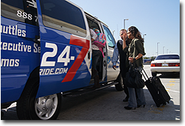
- Collect luggage at luggage claim
- Call 951-321-0707 to say you’ve arrived and give a description of your clothing
- AEI representative will inform the driver to pull up to designated pick-up zone
- Exit the terminal and wait by the curb
- Look for the vehicle that AEI describes to you
- If there are any problems, please contact AEI at 951321-0707/ Office: 951-824-6150 if you wish to cancel the airport pick-up, you must cancel at least ten (10) days prior to your flight date to receive the full refund.

TRANSPORTATION IN AND AROUND RIVERSIDE
For Bus Travel:
Riverside Transit Agency 951-565-5002
www.RiversideTransit.com
Greyhound 1-800-229-9424
www.greyhound.com

For Train Travel:
Metro link 1-800-371-5465
www.metrolinktrains.com

Amtrak: 800-872-7245 www.amtrak.com

For Shuttle Service:
Super Shuttle 909-467-9600 www.supershuttle.com
24-7 Ride 1-888-700-1222 www.24-7ride.com

For Car Rentals:
Enterprise Rent-A-Car 951-321-4130 www.enterprise.com

For Taxi Service (in town or to the airport):
Conduct an online search or use 1-800-829-4222. This is a taxi referral service that allows you to choose from several leading taxi services. It may be used in Riverside and in major cities all across the United States. Available 24 hours a day/ 7 days a week, 365 days per year.

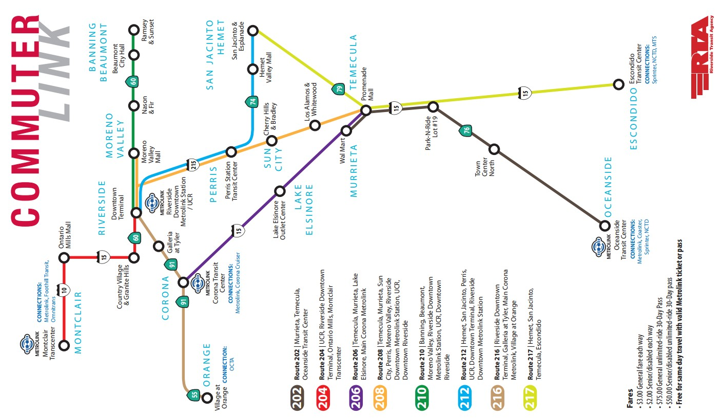

BANKS AND MONEY TRANSACTIONS
Students are encouraged to open a bank account if they plan to be in the U.S. for longer than 6 months. It is safer to keep your money in a bank than to carry large amounts of cash with you. Students should not carry large amounts of cash. They should carry only what they need for that day.
There are three banks located within two miles of American English Institute:
- Chase Bank, 1299 University Ave STE 105. Riverside CA 92507, (951)782-8805
- Wells Fargo Bank, 3750 University Ave Ste 150, Riverside, CA 92501, (951)782-2670
- U.S. Bank, 3625 Vine St, Riverside, CA 92507, (951) 512-1424

Checking Account
You will have a choice of several different types of checking accounts with different service fees. For example, you may get a reduced service charge if you use a small number of checks per month or no service charge if you are able to maintain a certain balance in your account. In addition, interest-earning checking accounts are available. Ask about the qualifications for this type of account. A checking account can be used to pay bills and provides a record of your payments. When paying for a purchase with a personal check, you will be required to present proper identification -such as a California Driver's License or ID card or Passport.

Please ask the bank representative for a student account so that you do not have to pay monthly fees.

Savings Account
All banking institutions offer savings account options. Savings and loan associations usually offer a slightly higher interest rate. The interest rates, amount of deposit and the length of time required for deposits vary with the different banking institutions. It is important to read the benefits AND requirements before opening a savings account. Some banking institutions will charge a fee for savings accounts while others do not.

Foreign Money Exchange
Foreign money may be exchanged at Bank of America. It is also possible to cash foreign checks, as well as international drafts and money orders at this bank; however, there may be a long waiting period to clear the money.

Traveler’s Checks
Traveler's checks are sold at all banks for a fee.

HEALTH INSURANCE POLICY

Health Care in the U.S.
You may encounter a time when you require urgent medical attention. Please note that the U.S. does NOT have free medical care. It is very expensive. Please refer to the information below regarding local Urgent Care and Emergency Services. For any medical service, you must show proof of health insurance coverage or be prepared to pay for this service yourself.

AEI’s Health Insurance Policy
If students do not have health insurance that covers them in the United States, they are highly encouraged to purchase AEI’s health insurance. If they choose not to have insurance, students must sign a Health Insurance Waiver.

AEI’s Health Insurance is $175 per 4-week session. Students may have to pay a small deductible to visit a doctor. However, this fee is very low compared to the cost of the actual visit. In the event of an emergency, health care costs can quickly be $5000 and up for a single visit to the emergency room.

Urgent Care
An urgent care clinic provides medical services to treat an illness or accident which is not life threatening but cannot wait for a scheduled appointment during regular doctor's office hours. Services are available during regular office hours, in the evening, and on weekends. Both the Riverside Community Hospital and the Riverside County Regional Medical Center have an Urgent Care Clinic on site. Some insurance companies (for example, Health Net or Kaiser) may designate certain medical facilities for non-emergency treatment. Be sure to verify any restrictions on your coverage and payment for medical services.

LOCAL MEDICAL FACILITIES

Emergency
In the event of a life threatening illness or accident, call 911 and ask for an ambulance. The injured person will be taken to the nearest hospital emergency room. Services are available every day of the week, 24 hours. (If you use the emergency room of a hospital for non-emergency treatment, you will have to pay higher fees for services.)

The following identifies the Emergency Room facilities closest to UCR:

Riverside County Regional Medical Center (Urgent Care and Emergency Services)
26520 Cactus Avenue Moreno Valley, CA 92555
Main Phone Number: 951.486.4000
Emergency Room: 951.358.2453

Riverside Community Hospital (Urgent Care and Emergency Services)
4445 Magnolia Avenue Riverside, CA 92501
Main Phone Number: 951.788.3000
Emergency Room: 951.788.3200

Parkview Community Hospital (Emergency Services)
3865 Jackson Street Riverside, CA 92503
Main Phone Number: 951.688.2211

Urgent Care

AFC Urgent Care
191 Alessandro Blvd #9a
Riverside, CA 92508
(951) 749-5511
8am-8pm

Raincross Urgent Care
4646 Brockton Ave, Riverside, CA 92506
(951) 774-2860
M-F: 2pm-9pm
S/SU:10am-8pm

Pharmacy & Clinic Services

Rite Aid Pharmacy
5225 Canyon Crest Dr. #8
Riverside CA 92507
951-684-5661

Ralphs Pharmacy
5225 Canyon Crest Dr.
Riverside CA 92507
951-784-3123

Riverside Medical Clinic 2660 Arlington Ave.
Riverside, CA 92507
951-697-5477

SAFETY

For EMERGENCIES:
Call 911

! POLICE ! FIRE DEPARTMENT ! AMBULANCE

For Non Emergencies
Call: Riverside Police Department (951) 826-5700

IMPORTANT SAFETY TIPS YOU MUST FOLLOWS:
- Always lock your home and car door.
- If someone knocks on the door at home, ask, “Who is it?” Do not open the door unless you know who is knocking.
- Do NOT leave anything valuable in the car in sight…put backpacks, cell phones, etc. in the trunk if you must leave the car or take with you.
- Pay attention to your surroundings. Look at who and what is around you.
- Walk in pairs when possible and not alone.
- Don’t talk on the cell phone or listen to music with headphones while walking.
- Don’t leave electronic devices or your purse unattended in the classroom or anywhere.
- Look at people as you’re walking. Don’t look down.
- If attacked, FIGHT BACK!
Install Strong Door and Window Locks
Apply the following recommendations ONLY with the approval of your landlord. Some of the recommendations may not be feasible for your particular circumstance.
- Install deadbolt locks on all outside doors. The bolt should extend at least one inch when in the locked position.
- Install auxiliary patio door locks to secure sliding glass doors. You may also use a sung-fitting piece of wood in the tracks for added protection.
- Secure your garage and tool shed. Burglars can enter your home through an attached garage, or they can use your tools to break in.
- Use your locks. Make sure all doors and windows are secure when you leave your house.

Teach Your Children Safety Tips Teach your children:
- How to call the police.
- Not to talk to strangers or accept rides from them.
- Not to play alone or in deserted places.
- Make sure your children carry some form of identification.
- Make sure your children fully understand the consequences of getting caught shoplifting or taking drugs.

While at Home
When the doorbell rings:
- Inspect who is at the door through the “peep-hole.”
- Ask the visitor to identify himself.
- Make sure the safety chain is attached before opening.
- Before talking to salesmen or repairmen, ask to see their credentials.
- If a stranger asks to use your phone, do not permit him/her to enter. Offer to make the call for him/her.
- Keep your valuables locked in a safe and concealed place. Remove wallets from pants left near the bedside.

If a burglar gains entrance to your home:
- Do not try to capture him.
- Lie still if you are in bed, or if you prefer, make some small noise to let him know you are awake. The burglar's main interest is most likely to escape.

Neighborhood Safety Tips
- When you see a suspicious person in your neighborhood, call the police to check him/her out. While waiting for the police to arrive, obtain the license number of his/her vehicle and a full description.
- When you witness a crime or traffic accident, call it in right away. Do not depend on others to call.
By taking a few simple precautions, you can reduce the risk to yourself, and also discourage those who commit crimes.

Earthquake Safety and Preparation
Southern California is an active earthquake zone. Earthquakes strike suddenly, violently and without warning; however, identifying potential hazards and preparation before an emergency can reduce the dangers of serious injury to you and your family.

What to Remember During an Earthquake:
If indoors:
- Take cover under a piece of heavy furniture or against an inside wall and hold on.
- Stay inside.
- The most dangerous thing to do during the shaking of an earthquake is to try to leave the building because objects can fall on you.
If outdoors:
- Move into the open, away from buildings, streetlights, and utility wires.
- Once in the open, stay there until the shaking stops. If in a moving vehicle:
- Stop quickly and stay in the vehicle.
- Move to a clear area away from buildings, trees, overpasses, or utility wires.
- Once the shaking has stopped, proceed with caution. Avoid bridges or ramps that might have been damaged by the quake.

After an Earthquake:
- Be prepared for aftershocks
  - Although smaller than the main shock, aftershocks cause additional damage and may bring weakened structures down.
  - Aftershocks can occur in the first hours, days, weeks, or even months after the quake.
- Help injured or trapped persons
  - Give first aid where appropriate.
  - Do not move seriously injured persons unless they are in immediate danger of further injury. c. Call for help.
- Listen to a battery-operated radio or television for the latest emergency information.
- Help your neighbors who may require special assistance (infants, the elderly, individuals with disabilities)
- Stay out of damaged buildings. Return home only when authorities say it is safe.
- Clean up spilled medicines, bleaches or gasoline or other flammable liquids immediately. Leave the area if you smell gas or fumes from other chemicals.
- Open closet and cupboard doors cautiously.
- Inspect the entire length of chimneys carefully for damage. Unnoticed damage could lead to a fire.
- General Safety in the Community
If you experience an earthquake, DON’T PANIC! Take cover and wait for shaking to stop.

CANCELLATION OF AGREEMENT

Student’s Right to Cancel
The student has the right to cancel the enrollment agreement and obtain a refund of charges paid through attendance at the first class session, or the seventh day after enrollment, whichever is later. You have the right to cancel this agreement for a course of instruction until midnight of the seventh business day after the first class you attended. Business day means a day on which you were scheduled to attend a class session. Cancellation shall occur when you give written notice of cancellation at the address of the school shown on the top of the front page of this agreement. You can do this by mail, hand delivery, or email. The written notice of cancellation, if sent by mail, is effective when deposited in the mail, properly addressed with postage prepaid. The written notice of cancellation need not take any particular form and, however expressed, it is effective if it shows that you no longer wish to be bound by this agreement.

Refund Policy
- Application fee is non-refundable.
- Housing deposits, homestay placement fee, airport pick-up fee if airport pick is requested, tuition, books and materials, health insurance and student services fees are non-refundable after the cancellation period.
- Failure to attend without notifying the school of withdrawal does not constitute withdrawal.
- Students will be issued a pro rate refund based on how many hours attended or were scheduled to attend. If attended over 60%, no refund is due.

Retention Of Student Records Policy
American English Institute shall retain documents for the following period of time.

All paper documents will be retained for a minimum of five years. Computer records will be retained for a minimum of ten years and as long as technology permits. This applies to all student records, personnel records, and documents associated with governmental agencies. This requirement meets or exceeds all present Federal or State requirements. However, all transcripts are retained permanently.

BUREAU FOR PRIVATE POSTSECONDARY EDUCATION (BPPE)
The State of California established the Student Tuition Recovery Fund (STRF) to relieve or mitigate economic loss suffered by a student in an educational program at a qualifying institution, who is or was a California resident while enrolled, or was enrolled in a residency program, if the student enrolled in the institution, prepaid tuition, and suffered an economic loss. Unless relieved of the obligation to do so, you must pay the state-imposed assessment for the STRF, or it must be paid on your behalf, if you are a student in an educational program, who is a California resident, or are enrolled in a residency program, and prepay all or part of your tuition. You are not eligible for protection from the STRF and you are not required to pay the STRF assessment, if you are not a California resident, or are not enrolled in a residency program.
It is important that you keep copies of your enrollment agreement, financial aid documents, receipts, or any other information that documents the amount paid to the school. Questions regarding the STRF may be directed to the Bureau for Private Postsecondary Education, 1747 N. Market Blvd. #225, Sacramento, CA 95834, (916) 574-8900 or (888) 370-7589, or internet www.bppe.ca.gov.
To be eligible for STRF, you must be a California resident or are enrolled in a residency program, prepaid tuition, paid or deemed to have paid the STRF assessment, and suffered an economic loss as a result of any of the following:
- The institution, a location of the institution, or an educational program offered by the institution was closed or discontinued, and you did not choose to participate in a teach-out plan approved by the Bureau or did not complete a chosen teach-out plan approved by the Bureau.
- You were enrolled at an institution or a location of the institution within the 120 day period before the closure of the institution or location of the institution, or were enrolled in an educational program within the 120 day period before the program was discontinued.
- You were enrolled at an institution or a location of the institution more than 120 days before the closure of the institution or location of the institution, in an educational program offered by the institution as to which the Bureau determined there was a significant decline in the quality or value of the program more than 120 days before closure.
- The institution has been ordered to pay a refund by the Bureau but has failed to do so.
- The institution has failed to pay or reimburse loan proceeds under a federal student loan program as required by law, or has failed to pay or reimburse proceeds received by the institution in excess of tuition and other costs.
- You have been awarded restitution, a refund, or other monetary award by an arbitrator or court, based on a violation of this chapter by an institution or representative of an institution, but have been unable to collect the award from the institution.
- You sought legal counsel that resulted in the cancellation of one or more of your student loans and have an invoice for services rendered and evidence of the cancellation of the student loan or loans.
To qualify for STRF reimbursement, the application must be received within four (4) years from the date of the action or event that made the student eligible for recovery from STRF.
A student whose loan is revived by a loan holder or debt collector after a period of noncollection may, at any time, file a written application for recovery from STRF for the debt that would have otherwise been eligible for recovery. If it has been more than four (4) years since the action or event that made the student eligible, the student must have filed a written application for recovery within the original four
(4) year period, unless the period has been extended by another act of law.
However, no claim can be paid to any student without a social security number or a taxpayer identification number.”
Amount of STRF Assessment: Beginning January 1, 2015, institutions are refrained from collecting STRF.
STRF Assessment Fee
The Student Tuition Recovery Fund (STRF) fee collected by the institution is payable to the BPPE and is non-refundable to the student.

Notice Concerning Transferability of Credits and Credentials Earned at Our Institution
The transferability of credits you earn at American English Institute is at the complete discretion of an institution to which you may seek to transfer. Acceptance of the Certificate of Merit you earn in Intensive English Program, Semi-Intensive Program, or TOEFL Preparation Program is also at the complete discretion of the institution to which you may seek to transfer. If the Certificate of Merit that you earn at this institution is not accepted at the institution to which you seek to transfer, you may be required to repeat some or all of your coursework at that institution. For this reason, you should make certain that your attendance at this institution would meet your educational goals. This may include contacting an institution to which you may seek to transfer after attending American English Institute to determine if your Certificate of Merit will transfer.
The Office of Student Assistance and Relief
The Office of Student Assistance and Relief is available to support prospective students, current students, or past students of private postsecondary educational institutions in making informed decisions, understanding their rights, and navigating available services and relief options. The office may be reached by calling (888-370-7580) or by visiting www.osar.bppe.ca.gov

CONTACTING BPPE
Questions: Any questions a student may have regarding this catalog that have not been satisfactorily answered by the institution may be directed to the Bureau for Private Postsecondary Education at:
1747 N. Market Blvd. Ste 225 Sacramento, CA 95834
or
P.O. Box 980818, West Sacramento, CA 95798-0818

www.bppe.ca.gov

Toll-free telephone number: (888) 370-7589 or fax number: (916) 263-1897
Telephone: (916) 431-6959 or by fax (916) 263-1897

Complaints: "A student or any member of the public may file a complaint about this institution with the Bureau for Private Postsecondary Education by calling (888) 370-7589 toll-free or by completing a complaint form, which can be obtained on the bureau's Internet Web site (www.bppe.ca.gov).

ATTRACTIONS IN SOUTHERN CALIFORNIA & RIVERSIDE

The following is a selection of activities and attractions that you may want to visit during your stay in beautiful
Southern California. If you need help visiting one of these destinations or another place, please ask us! We can help

you to arrange transportation and lodging and tickets.

Attractions in the Inland Empire:
The Mission Inn, Riverside, CA
2649 Mission Inn Ave. Riverside CA 92501
The Historic Mission Inn Hotel and Spa
Mission Inn Museum

Riverside Plaza
Shopping/ Movie Theater
2545 Central Ave. Riverside CA 92506

Tyler Mall
1299 Tyler St. Riverside CA 92503
951-351-3170

Moreno Valley Mall
22500 Town Cir. Moreno Valley CA 92553
951-653-1177

Ontario Mills Mall
1 Mills Cir. Ontario, CA 91764
909-484-8300

Victoria Gardens Shopping Center
12505 N. Mainstreet #200 Rancho Cucamonga,
CA 909-463-2830

Big Bear CA
Big Bear Discovery Center
Big Bear Solar Observatory
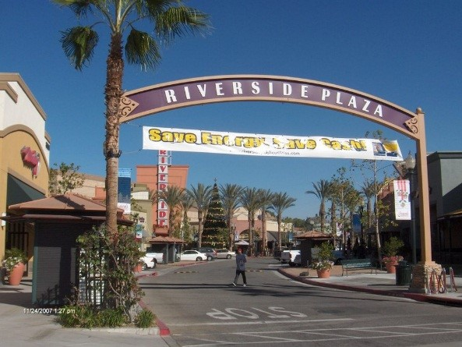





Popular Southern California Attractions:
Disneyland and California Adventure

California Science Center

Huntington Library, Art Gallery and Botanical
Gardens
Library, Art Gallery and Botanical Garden

Getty Center
J. Paul Getty Museum and Getty Villa (Malibu)

Joshua Tree National Park

Knott’s Berry Farm, Buena Park
Knott’s Berry Farm Amusement Park
Knott’s Soak City Waterpark

Los Angeles Zoo and Botanical Gardens

San Diego, CA
San Diego Zoo, Sea World, San Diego Safari Park

Six Flags
Magic Mountain
Hurricane Harbor

Universal Studios

