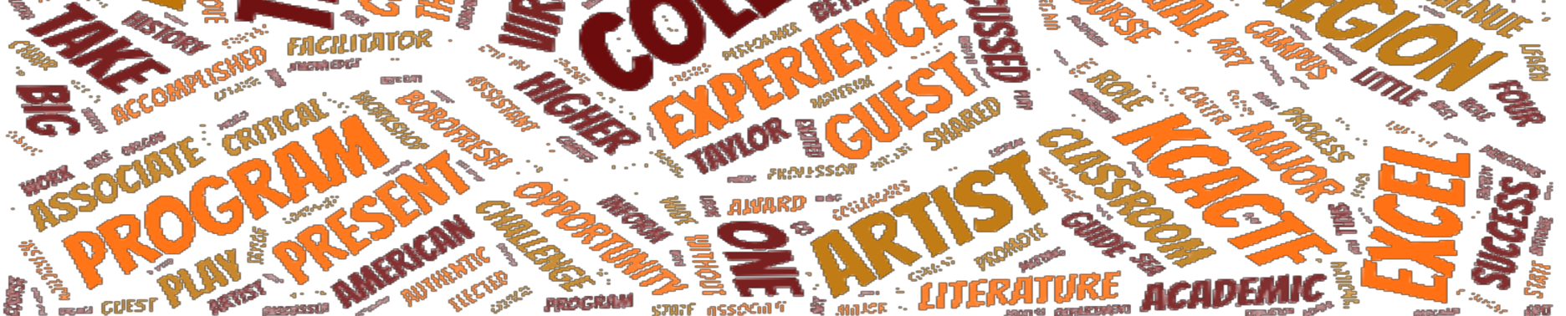
My academic and artistic leadership philosophy borrows equally from a democratic, transformational, and solution-based styles. I most value courage, authenticity, and collaboration with my colleagues. I am a firm believer in gathering consensus and fostering widespread buy-in. I am also a pursuant of “what if?” and employ, “yes and…” in most situations.
As a strong leader, I believe that inspiring colleagues to speak their mind, with candor and honesty leads to the most exciting possibilities. When all parties have a voice at the table, consensus happens more quickly; new ideas and initiatives breeds success & excitement.
Teaching is an art requiring specific skill sets and a demeanor that respects and cares for the whole student, and an effective leader encourages learning to be robust, respectful, and exciting. Additionally, I believe decimating obstacles that hinder students from learning deeply and intimately, through an equity lens, is paramount to successful leadership.
As a leader, I function more like a guide than a dictator, creating an environment where learning to think critically, (re)acting to material, and challenging preconceived ideas with presence and resistance is spotlighted.
I reject the notion of autocratic leadership in preference to gathering consensus and hearing all voices at the table, a hallmark of a democratic leadership philosophy. With community buy-in, I believe that transformational results are possible. Looking practically and theoretically at how performing arts can be used as a powerful tool to understand the human experience, with vigor and consistency, it is my job to train students to examine their own critical eye and insist that they stretch themselves as scholars and practitioners. I expect the same from my colleagues.
To provide a venue for colleagues to excel, I believe that fostering an environment where risk taking is encouraged and supported; authenticity ensues. As a leader in higher-education, I believe that the classroom should be a meeting ground for understanding, acquisition, and expanding knowledge. Through shared experience grounded in truth, theory, and practical knowledge, I set out to create a diverse environment for authenticating practical skills.

