SIMON HARRISON
REAL ESTATE
BROKERING THE HAMPTONS

EXCLUSIVE RIGHT TO SELL MARKETING AGREEMENT
I, , do hereby agree that Simon Harrison Real Estate, LLC shall have the

exclusive right to sell my property located at
, (SCTM # ).
_ New York,

This agreement shall commence , 2021 and continue for a period of 12 months. The price shall be $ ( Dollars), or any other price, which I agree to, which includes a six percent (6%) commission.

You confirm that the property is not listed with any other real estate broker or agency, and you agree not to list the property with any other broker or agency during the term of this agreement. You also confirm that you have the sole legal right to enter into this agreement whereby you are in title or have been legally assigned such right.

We agree to offer the property at every opportunity to qualified buyers. You authorize SHRE to advertise the Property, publish its address, post a for sale sign on the Property, and coordinate the efforts of select area brokers with whom this listing shall be co­ brokered. SHRE will conduct all appointments and negotiations. You will refer to SHRE promptly all inquiries concerning the Property that you receive, and you shall conduct through SHRE all negotiations with respect to the sale of the Property.

The commission will be six percent (6%) of the actual selling price. The commission will be earned when a ready, willing and able buyer is procured, and you have agreed to the price and terms. As an accommodation to Seller, the commission may be payable upon
title closing. If the property is sold by you directly, or by an agency with whom SHRE does not have a co-broke agreement, the commission of 6 percent (6%) shall be due and payable to SHRE upon demand. If the Contract of Sale is assigned by the purchaser, the
full commission shall be due immediately to SHRE upon assignment. The commission shall be six percent (6%) of the sales price in the Contract of Sale between you and the purchaser or assignee.

Should closing of title not occur for any reason whatsoever, except willful default of the Seller, there shall be no commission due.

In accordance with New York State law, you acknowledge: (a) you have received a copy
of the "New York State Disclosure Form for Buyer and Seller"; (b) It is agreed that this Property be listed in full compliance with local, and federal fair housing laws against discrimination on the basis of race, color, religion, sex, national origin, handicap, age,
marital status and/or familial status, or other prohibited factors; (c) that if you elect not to deliver a completed Property Condition Disclosure Statement to the buyer of your

property prior to the buyer signing a contract of sale, you will credit the buyer $500.00
against the purchase price of the property upon transfer of title.
This agreement: (a) supersedes all prior agreements and understandings between the parties relating to the subject matter hereof; (b) shall bind and benefit the parties hereto and their respective heirs, personal representatives, successors and assigns; (c) may not be changed, rescinded or modified except in writing, signed by the parties hereto; and (d) shall be governed and construed in accordance with the laws of New York State.

At the time of closing, you may be required to deposit the broker's commission with the county clerk in the event that you do not pay the broker his or her commission as set forth herein. Your obligation to deposit the broker's commission with the county clerk may be waived by the broker.

Please sign this agreement below and return one copy to us together with the required New York State Agency Disclosure Form. Should you have any questions or concerns, please contact our office at once.

An "Exclusive Right to Sell" listing means that if you, the owner of the property find a buyer for your house, or if another broker finds a buyer, you must pay the agreed commission to the present broker. We agree to offer the property at every reasonable opportunity to qualified buyers, and will coordinate the efforts of select area brokers with whom this listing may be co-brokered.

All appointments and negotiations will be conducted by Simon Harrison Real Estate, LLC. If a contract of sale is initiated within one hundred and twenty days (120) after the termination of this agreement with a person or their assigns that was procured as a prospective purchaser as provided above, then we shall be compensated hereunder, if, when, and as title passes to such a person. Should you withdraw your property from sale prior to the expiration of this agreement, you agree to pay for reasonable advertising costs to Simon Harrison Real Estate, LLC upon withdrawal.

Homeowner

Simon Harrison, Principal Broker

(631) 725-4357 OFFICE (631) 899•2998 • FAX
Dated

Dated

#6 LONG WHARF PROMENADE PO Box 2001
SAG HARBOR, NY 1 1 963

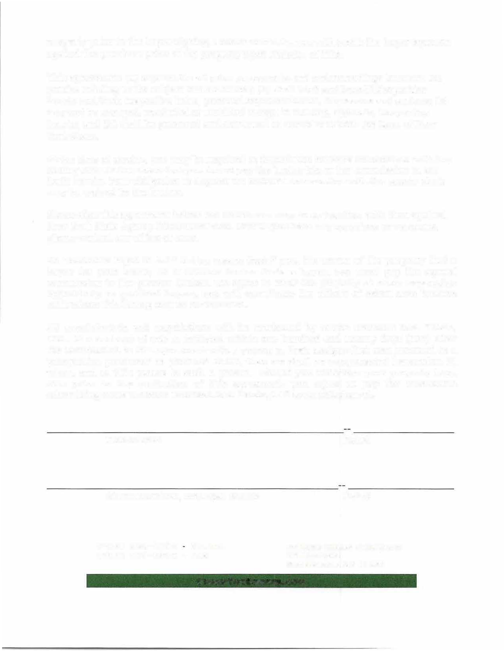
S!MONTHEBROKER.COM

