FALSIFIABILITY IN THE THEORY OF EVERYTHING
Experimental Tests, Mathematical Formulations, and Consciousness Programming Integration

Experimental Setup Overview
All six core experimental tests for falsifying the Theory of Everything:
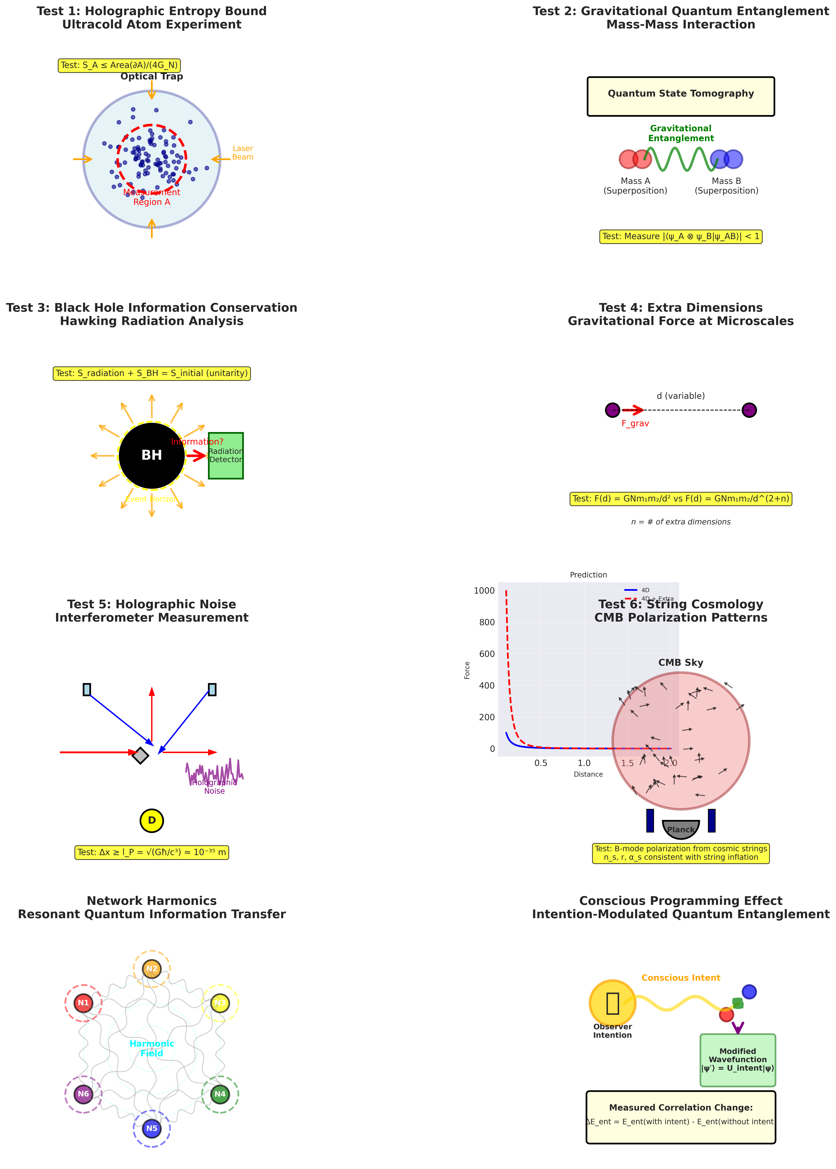

TEST 1: Holographic Entropy Bound
Prediction: S_A ≤ Area(∂A)/(4G_N)
Method: Ultracold atoms in optical traps
Falsified if: S_measured > Area/(4G_N)

TEST 2: Gravitational Entanglement
Prediction: Gravity creates quantum entanglement
Method: Levitated nanoparticles in superposition
Falsified if: No entanglement detected

TEST 3: Black Hole Information
Prediction: S_total conserved (unitarity)
Method: Analog black holes in BEC
Falsified if: Information demonstrably lost

TEST 4: Extra Dimensions
Prediction: F(d) ∝ d^-(2+n) at small scales
Method: Torsion balance at microscales
Falsified if: Perfect 1/r² to Planck scale

TEST 5: Holographic Noise
Prediction: Δx × Δy ≥ l_P²
Method: High-precision interferometry
Falsified if: No noise at Planck scale

TEST 6: String Cosmology
Prediction: Specific CMB parameters
Method: Satellite CMB observations
Falsified if: Parameters outside string theory range

Mathematical Framework
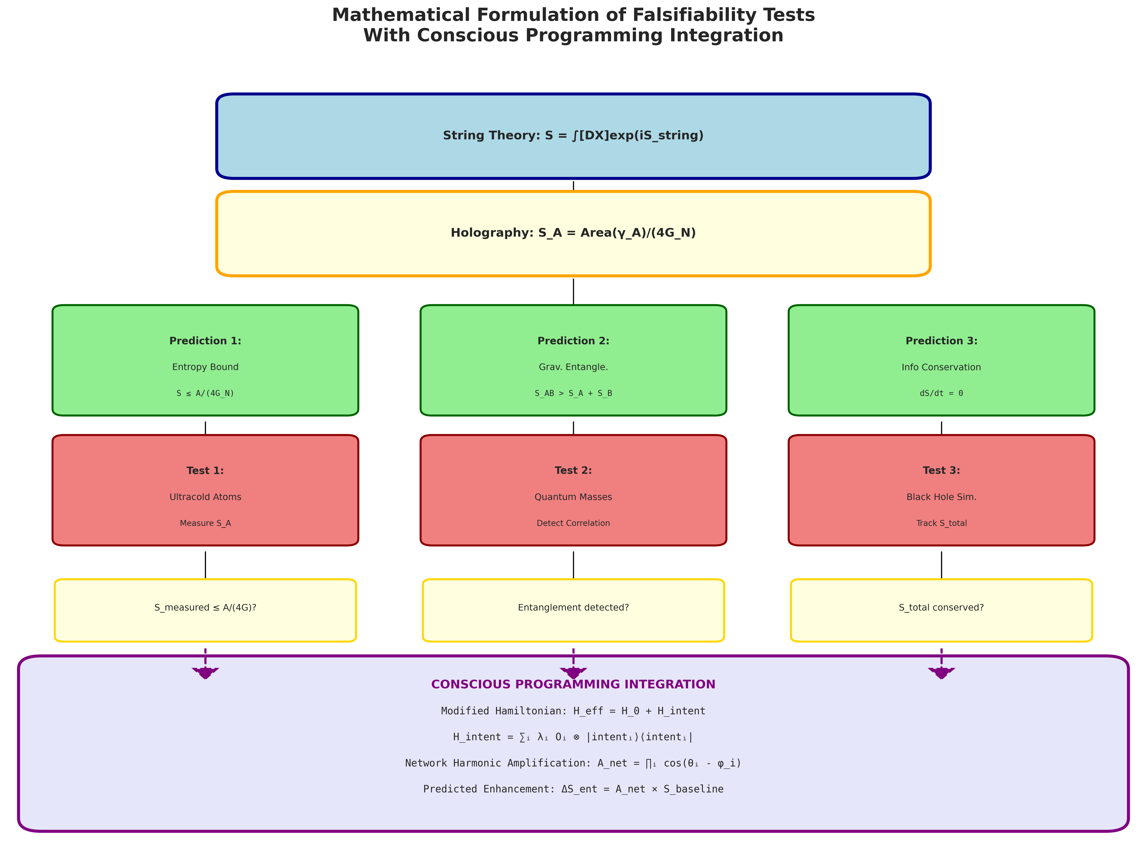

NETWORK HARMONICS
Resonant quantum information transfer across entangled networks:
Enhancement Factor: A_net = ∏ᵢ cos(θᵢ - φᵢ)
At resonance: Effect ~ Q × N²

CONSCIOUS PROGRAMMING EFFECTS
Modified Hamiltonian: H_eff = H_0 + H_intent
Predicted entanglement change: ΔS ~ A_net × C_coherence × N²
Rigorous double-blind testing required
Falsified if: No effect detected with p < 0.001
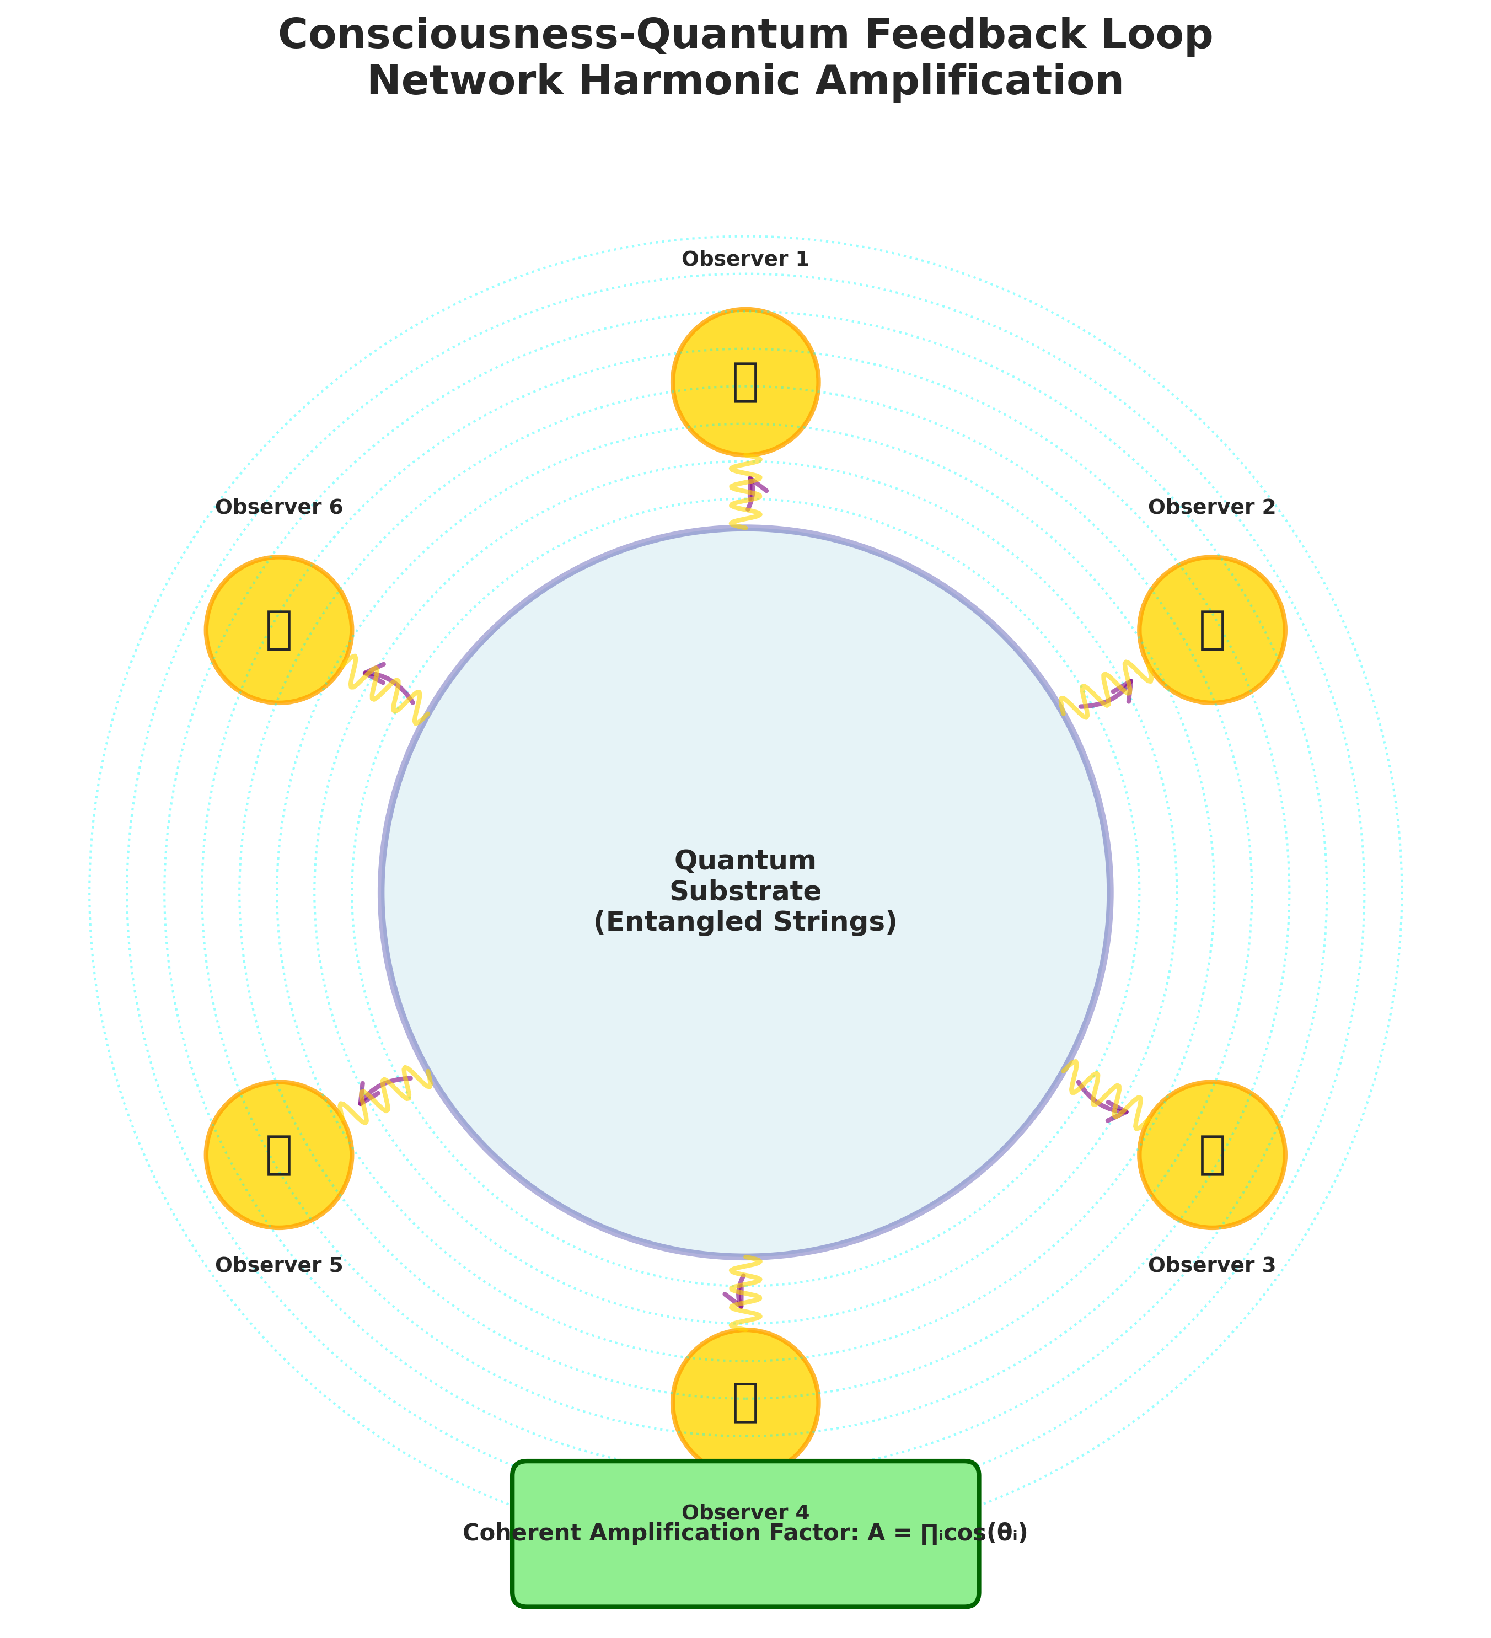

INTEGRATED FRAMEWORK
Complete theory:
Reality = Holographic[Entanglement[Strings]] × Network_Harmonics × Conscious_Programming

Modified Ryu-Takayanagi:
S_A = [Area(γ_A)/(4G_N)] × [1 + α_net A_net + α_conscious C_coherence]

TIMELINE FOR RESULTS
2025-2030: Core tests (entropy bounds, gravitational entanglement, BH info)
2030-2040: Advanced tests (extra dimensions, holographic noise, cosmology)
2040-2050: Network harmonics and consciousness effects
By 2050: Framework validated or falsified

CONCLUSION
The Theory of Everything is FALSIFIABLE. Six specific experimental tests, plus network and consciousness effects, will determine over the next 25 years whether this framework correctly describes reality or requires fundamental revision.
Science advances through bold predictions and rigorous testing.
The Theory of Everything makes both.
Now we wait for nature to speak.

