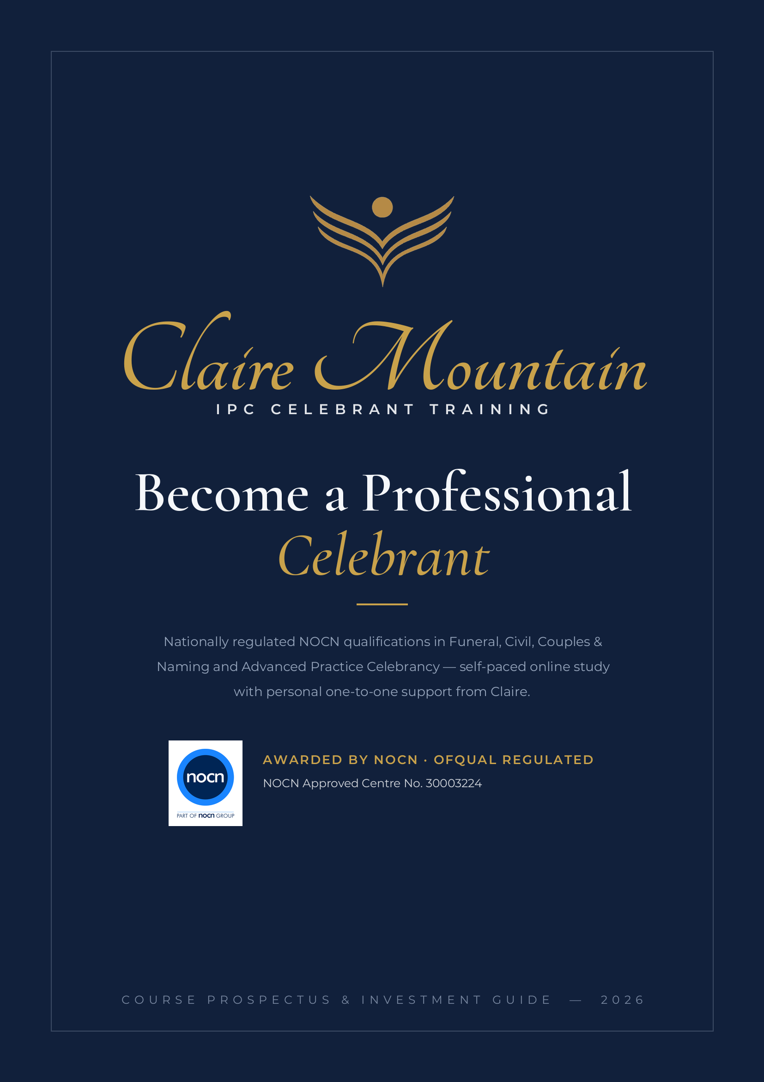

A PROFESSION OF CARE
Training celebrants to hold families
through life’s most significant moments

Becoming a celebrant is a calling to serve people at the threshold of their most profound experiences — the loss of someone they love, the joining of two lives, the welcoming of a child. It deserves training of equal seriousness.
IPC Celebrant Training delivers nationally regulated NOCN qualifications led personally by Claire Mountain, Director of Industry Training. Over the past decade Claire has trained and mentored a community of professional celebrants who have gone on to build successful, independent practices across the UK and internationally — many maintaining lasting professional relationships with Claire long after qualifying.
This is not a weekend workshop or an informal certificate. Every programme is a regulated qualification, individually tutored and assessed to the standard the profession — and the families you will serve — rightly expect. You finish credible, competent and ready to practise.
1:1  Personally Supported  Self-paced study, with monthly one-to-one meetings with Claire and unlimited WhatsApp contact throughout your course. | 12  Months to Complete  Start whenever you are ready and study entirely at your own pace, with a full twelve months to complete. | 100%  Online & Regulated  Ofqual-regulated, NOCN-awarded qualifications delivered through guided online modules — recognised across the UK and beyond.

THE LEARNING EXPERIENCE
Premium, personal, and built
entirely around you

Our model is deliberately different from large online cohorts. You study at your own pace, with genuinely personal support from Claire and real professional exposure to the settings you will work in.
WHAT EVERY CELEBRANCY QUALIFICATION INCLUDES
✓ Unlimited WhatsApp access to Claire to ask questions and discuss the course throughout. | ✓ Complete digital resource suite — lessons, templates, briefs and submission materials.
✓ Start at your leisure and learn at your own pace, on your own schedule. | ✓ Optional shadowing alongside a practising, working celebrant.
✓ Twelve months to complete, with extensions considered where appropriate. | ✓ Venue, funeral home & crematorium visits available to ground your learning in practice.
✓ One-to-one online induction with your Senior Trainer & Assessor. | ✓ NOCN digital certificate on successful completion.
✓ Monthly progress meetings with structured, written feedback on every submission. | ✓ All NOCN registration & EQA fees included — no hidden costs.
YOUR SUPPORT MODEL
This is a self-study qualification — you work through the structured online modules independently, at your own pace and in your own time. Your one-to-one time with Claire takes the form of a monthly online meeting to discuss your progress and talk through assignment feedback. Between those meetings you have unlimited WhatsApp access to Claire to ask questions and discuss any aspect of the course — so you are studying independently, but never on your own.
HOW YOU ARE ASSESSED
Assessment is supportive rather than pass/fail. You demonstrate your competence through practical tasks, written ceremony scripts and professional documentation, and video recordings of your ceremonial delivery — reviewed personally by an experienced assessor who works with you until your work meets the required professional standard. Every assessment decision is valid, authentic, current, sufficient and reliable, and internally quality assured in line with NOCN requirements.
PROFESSIONAL EXPOSURE (SUBJECT TO AVAILABILITY)
Where accessible, your programme can include shadowing a working celebrant and arranged visits to ceremony venues, funeral homes and crematoria — so you step into your first ceremony already familiar with the environment and the people in it.

CHOOSE YOUR PATHWAY
Regulated qualifications for
every Celebrancy career

Civil Celebrancy Certificate NOCN LEVEL 3 CERTIFICATE · 18 CREDITS · 180 HOURS · QUAL. 601/2508/1
Your professional foundation. A regulated standalone qualification covering both civil funeral services and celebratory ceremonies, and the ideal entry point and pathway into the full diplomas.
EIGHT MANDATORY UNITS
Understanding Professional Civil Celebrancy in the UK  T/505/8447 | Planning and Delivering Celebratory Civil Ceremonies in the UK  T/505/8450
Health and Safety Considerations for Civil Celebrants  A/505/8448 | Understanding the UK Funeral Industry  D/505/8457
Valuing Equality and Diversity  L/503/1013 | Working with the Bereaved  H/505/8458
Understanding Celebratory Civil Ceremonies in the UK  F/505/8449 | Creating and Conducting a Civil Funeral Service  K/505/8459
Funeral Celebrancy NOCN LEVEL 3 DIPLOMA · 54 CREDITS · QUAL. 601/1587/7
The complete professional qualification for those called to support bereaved families — from first interview through to creating and delivering dignified, personalised funeral ceremonies.
SEVENTEEN MANDATORY UNITS
The UK Funeral Industry  H/503/6914 | Memorial Ceremonies  H/503/6931
Interviewing the Bereaved  Y/503/6926 | Scattering or Interring of Ashes  J/651/1151
Communicating with Clients  H/651/1150 | Understanding the Impact of Diversity on Funeral Ceremonies  K/618/5593
Creating a Funeral Ceremony Script  A/503/6921 | Accommodating Individuals with Additional Needs  R/503/6925
Writing Funeral Tributes  D/503/6930 | Health and Safety for Funeral Celebrants  J/503/6923
Delivering a Funeral Ceremony  F/503/6922 | Software and IT Skills for Funeral Celebrants  D/618/5591
Managing Funeral Ceremony Choices  D/503/6927 | Email Skills for Funeral Celebrants  H/618/5592
Funerals with Secular Content  M/618/5594 | Business Management Skills for Funeral Celebrants  A/651/1149
Funerals with Religious or Spiritual Content
T/618/5595

CHOOSE YOUR PATHWAY
Couples & Naming Ceremonies NOCN LEVEL 3 DIPLOMA · 41 CREDITS · QUAL. 601/1586/5
The complete qualification for celebratory practice — designing and delivering bespoke weddings, commitments, vow renewals and naming ceremonies, and building the business behind them.
THIRTEEN MANDATORY COMPONENTS
Naming and Couples’ Ceremonies in the UK  K/504/0429 | Managing Ceremony Venues  H/504/0428
Planning Naming & Couples Ceremonies with Clients  R/651/0336 | Equality and Diversity for Celebrants  Y/651/0338
Couples’ Ceremony Content  T/504/0420 | Health & Safety for Naming and Couples Celebrants  T/651/0337
Naming Ceremony Content  K/504/0432 | Business Management Skills for Celebrant  H/651/0340
Creating a Ceremony Script  A/504/0421 | Email Skills for Celebrants  A/651/0339
Delivering Naming and Couples Ceremonies  F/504/0422 | Word Processing Software  R/502/4628
Managing Ceremony Choices
D/504/0427
Advanced Practice Funeral Celebrancy NOCN LEVEL 4 DIPLOMA · 58 CREDITS · QUAL. 610/2743/1
The next step for experienced practitioners. A portfolio-based qualification that formally evidences advanced practice — including the specialist content to practise as a Child & Baby Funeral Celebrant. Built through your real work with real clients.
NINETEEN MANDATORY UNITS
Advanced Practice in Writing Skills for Funeral Ceremonies  A/650/7351 | Advanced Practice for Ashes Ceremonies  H/650/7354
Advanced Practice in Verbal Delivery Techniques  D/650/7352 | Advanced Inclusivity for Funeral Ceremonies  L/650/7357
Advanced Practice in Non-Verbal Delivery Techniques  J/650/7355 | Improving Inclusivity at Funeral Ceremonies  Y/650/7332
Advanced Delivery of Poetry and Readings  K/650/7329 | Conduct Bereavement Interviews in Challenging Circumstances  K/650/7338
Understand Poetry and Readings for Funeral Ceremonies  Y/650/7314 | Understand Challenging Circumstances in Bereavement Interviews  H/650/7318
Rhetorical Techniques for Funeral Ceremonies  D/650/7325 | Understand the Role of a Celebrant in Challenging Interviews  A/650/7299
Storytelling Techniques for Funeral Ceremonies  J/650/7319 | Creating & Delivering Child and Baby Funeral & Ashes Ceremonies  F/650/7335
Advanced Practice in the Use of Music  F/650/7353 | Understand the Context of Child and Baby Funerals  K/650/7300
Understand the Technology for Music, Webcasting & Visual Imagery  T/650/7313 | Working with Bereaved Parents  Y/650/7298
Advanced Practice for Memorial Ceremonies
K/650/7356

COURSE FEES
Transparent investment,
everything included

Every fee below includes all NOCN registration and External Quality Assurance costs, your full resource suite, one-to-one tuition and your digital certificate. No hidden fees.
QUALIFICATION | LEVEL | INVESTMENT
Civil Celebrancy Certificate  601/2508/1 · 18 CREDITS | L3 CERTIFICATE | £1,800
Couples & Naming Ceremonies  601/1586/5 · 41 CREDITS | L3 DIPLOMA | £1,500
Funeral Celebrancy  601/1587/7 · 54 CREDITS | L3 DIPLOMA | £2,500
Dual Qualification Pathway BEST VALUE  FUNERAL + COUPLES & NAMING · SAVE £500 | 2 × L3 DIPLOMA | £4,000 £3,500
Advanced Practice Funeral Celebrancy  610/2743/1 · 58 CREDITS · INCL. CHILD & BABY | L4 DIPLOMA | £2,600
Dual Pathway saving applies when both Level 3 diplomas are taken together. Payment plans may be available — please ask.
ASSESSOR & QUALITY ASSURANCE QUALIFICATIONS
For celebrants and training professionals progressing into assessing and quality assurance, we also offer the following NOCN qualifications:
Understanding the Principles & Practices of Assessment £550  L3 Award | Assessing Vocational Achievement (CAVA) £980  L3 Certificate
Understanding Internal Quality Assurance £550  L4 Award | Internal Quality Assurance £395  L4 Award
Leading Internal Quality Assurance £650
L4 Certificate
Assessor and IQA qualifications are theory-based, self-paced online programmes, typically completed in 3–8 weeks, with all NOCN registration and certification included.

