Dr. Darlene M. Urquhart
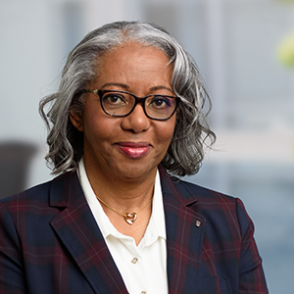 Dr. Darlene M Urquhart, President, The Darielle Group, LLC.
Ed.D, Executive Leadership Program (ELP), the George Washington University || MS, Business Management, Boston University || BA, Business Management, North Carolina State University || Executive Chief Learning Officer Certification, George Mason University || Executive Coach Certification, Georgetown University.
As a retired Army Officer, senior Department of Defense civilian, executive/leadership coach, and now President of the Darielle Group, LLC, Dr. Urquhart is passionate about leadership and the organizational structures in which those leaders serve. With a proven track record of working with senior acquisition leaders in the Department of Defense, Dr. Urquhart excelled at helping leaders transform multi-million/billon dollar programs. Dr. Urquhart has demonstrated expertise in organizational change, team/relationship building, strategic and tactical planning, critical thinking, and executive coaching. Drawing on rigorous academic training at the doctorate level predicated on four foundational pillars: organizational change, organizational culture, leadership, and learning (individual and organizational), along with practical expertise in leading complex organizations through change, Dr. Urquhart is an expert in helping organizations create strategic change initiatives and cultural transformations that are both executable and sustainable.
Dr. Urquhart is passionate about the transformational power of executive/leadership coaching. As a member of the senior executive staff of the Defense Acquisition University, Dr. Urquhart was the Coaching Champion for the Capital and Northeast Region responsible for nominating/selecting, training, and work-loading 10 executive coaches in service to senior executives in Defense. In corollary with executive coaching, Dr. Urquhart served as a consultant to major program offices and senior leaders for complex acquisition issues/problems. Simultaneously performing roles of senior leader, teacher, consultant, and executive coach shaped Dr. Urquhart’s coaching philosophy of improving strategic organizational goals/objectives/metrics in addition to performance improvements in the individual client. Creating alignment between bottom line organizational metrics and individual professional development initiatives creates a true win-win for the individual and the organization.
Dr. Urquhart’s experience with Defense has honed a globalist mindset. Having deployed to many parts of the world as an active-duty military officer and Defense civilian has helped to shape core philosophies related to the leadership, teamwork and collaboration, and a myriad of other perspectives that embrace diversity and inclusion from multiple perspectives: race, gender, orientation, thought.

