PROJEcT

TITLE

SOME RESTRICTIONS
FOR THE PREVENTION AND PROTECTION
AGAINST COVID 19
IN SUPPORT OF 500 PUPILS IN THE CATHOLIC SCHOOL « PERE AUGUSTIN PLANQUE » FROM AFIDEGNIGBA IN TOGO BETWEEN 2021-2022

Project bearer : Institute of the Sisters of Our Lady of Apostles (OLA) - District of TOGO
Total cost of the project: 9.839.850 FCFA (17,665.80 U.S. dollars)
LOCAL contribution : 500.000 F (897.67 U.S. dollars)
Funding requested: 9.339.850 (16,768.13 U.S. dollars)
1 U.S. dollar - 553.86 on November 19th, 2020.

Project Reference : Sœur (Pauline) BITANGA Akou Wayemba
B.P. 4796 LOME, Bè-KAMALODO – TOGO / Tel: (00228) 93 71 01 85
E-mail : paulebit@yahoo.fr

JUSTIFICATION OF THE PROJECT
This project is an approach solution to delaying the pandemic of the coronavirus among our learners.
Since the beginning of the Coronavirus pandemic (COVID-19), the Togolese government, like other countries, has enacted several measures to control the risk of spreading of the virus. These restrictions include: the regular handwashing with soap and water, the use of the hydro-alcoholic disinfectants or hand sanitizers, the prohibition of touching the eyes, nose or mouth, the wearing of face masks in public.
All these measures are good and mandatory for everyone without exception. But the country has provided just a little of means to support the population. Mostly everyone is to get what he/she needs to comply with the restrictions while the majority of our learners come from poor families and our means do not permit us to provide them with what is necessary. While the spread of the pandemic seems to being controlled in Togo, the fear of its spread is far from being over. Most institutions have these devices put in places most at risk of COVID-19 contamination that will also be more than necessary in schools since the smallest students (pupils) regularly put their hands to their mouth, nose, ears. This is what pushed us to turn to you for help for allowing our learners, the administration, the canteen ladies and anyone who enters the school to observe the restrictions and thus help save lives. Hence the importance of this project.
Our overall goal is to reduce the risk of coronavirus contagion in the population and especially among the 300 learners in our school.

Specific goals
- Ensure sanitary protective facilities and equipment.
- Offering a few meals to children from kindergarten to in-house.
- Make students aware of the compliance with the restrictive measures.
- Register in our school zero infected cases of COVID-19.
Results
- the 3 toilets are built.
- all 10 taps are installed.
- 1 summer hut, 10 benches and 1 table are made.
- cleaning products, food, 500 thermometer and 500 facemasks are purchased.
- Awareness is made and each beneficiary correctly complies with the recommended hygienic measures.
Activities
- Construction of 3 toilets.
- Installation of 10 handwash faucets.
- Purchase of cleaning products, 500 thermometer, 500 washable facemasks, food.
- Making of a summer hut, 10 benches and 1 table to serve.
- Raising awareness on restrictive measures.

QUELQUES IMAGES DE CERTAINS APPRENANTS

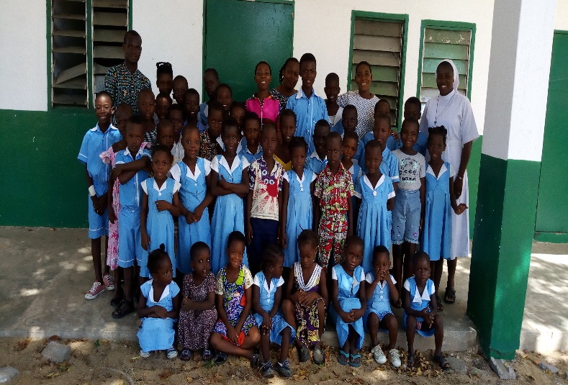
un groupe d’enfants avec la sœur directrice

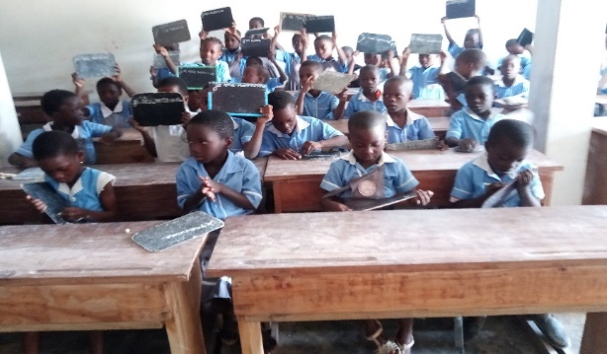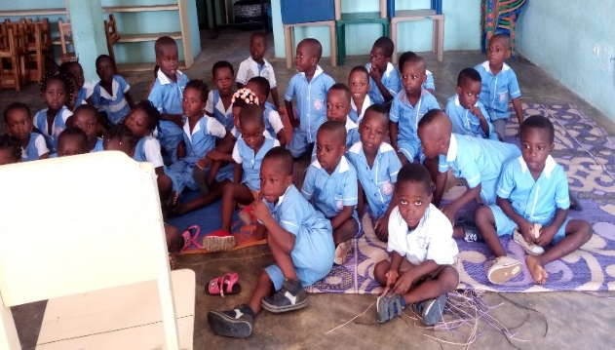
les apprenants en classe les enfants du jardin

