SAMAI WELL PROJECT FINAL REPORT

BYATISO Aurelia Sika
For SOMAGG
2/4/2020

CAME GOLD LTD
CONSULTANT IN PROJECT MANAGEMENT

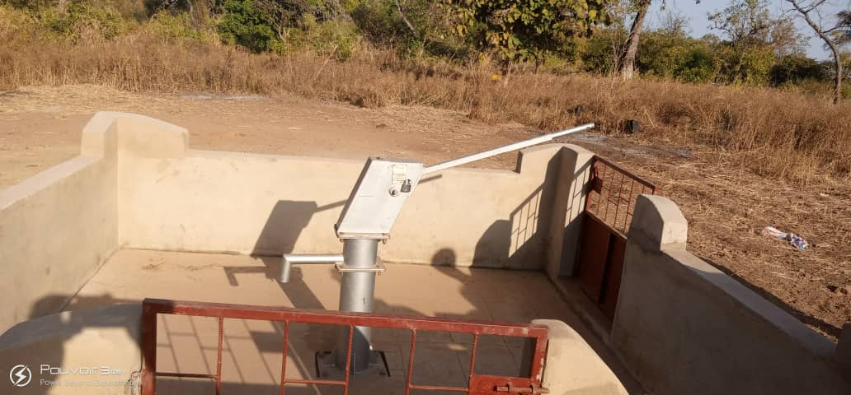
Table of Contents
I. SCOPE 3
Fig. 1- View of site before digging of well. Marking of the Area 3
Fig. 2- Prospection of the Area 3
II. TIME FRAME 4
III. ACTIVITIES 4
a) GEOGRAPHICAL INTROSPECTION 4
Fig.3- Conveying of digging truck 1 to the site 4
Fig.4- Conveying of digging truck 2 to the site 5
b) DIGGING OF WELL 5
Fig. 5- Machine digging well, Phase 1 5
Fig. 6- Machine digging well, Phase 2 6
Fig. 7- Machine digging well, Phase 2 7
Fig. 8- Machine digging well, Phase 2 7
c) WALL BUILDING 7
• Fig. 9 – Fig. 12 – Wall building 7
d) BOREHOLE PUMP INSTALLATION 9
• Fig. 13- Fig. 16- Pump installation and pumping trials. 9
e) INAUGURATION 11
Fig. 17- A community leader addressing the people before the blessing 11
Fig. 18 – Fr. Mathias blessing the Well with Fr. Joel 12
Fig. 19 – Fr. Mathias exercising some pumping 12
Fig. 21 – The chief of the community trying joyfully some pumping 13
Fig. 22 – A member of the community drinking from the Well 13
Fig. 23- Fr. Mathias receiving donation from the people of the community 14
IV. CONSTRAINTS 14
V. CONCLUSION 14

SAMAI (AFOSSALAKOPE) WELL PROJECT 2020/SOMAGG
- SCOPE
The SAMAI well project was intend to provide water by digging a borehole for a community at SAMAI (an outstation of Affossalakope Parish) a town found in the Central Region of Togo a country of West Africa.
This project was funded by Jim and Ann-Marie BABISH through Our Lady of Fatima Catholic Church of Sudbury (USA) and was executed by SOMAGG.
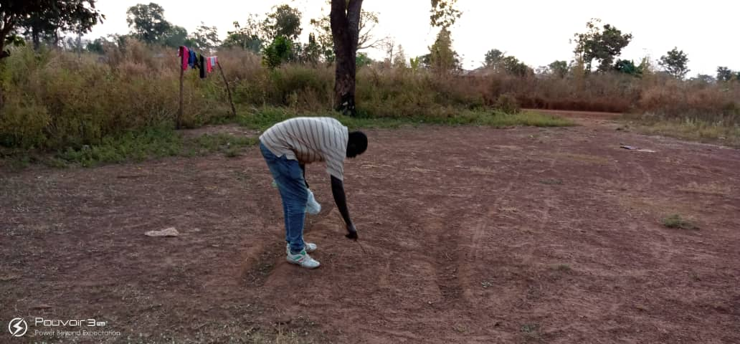

Fig. 1- View of site before digging of well. Marking of the Area

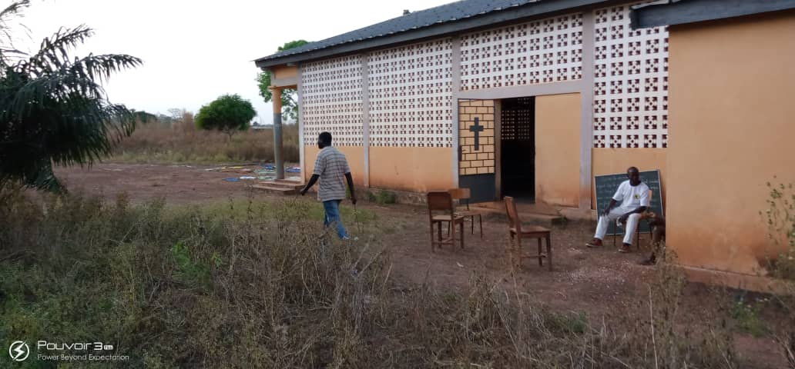

Fig. 2- Prospection of the Area

- TIME FRAME
The project was executed for a total of 1 month and half, beginning from November 30th 2019 to January 10th 2020.
Work started as soon as funds were received on November 28th 2019.
- ACTIVITIES
The work was done in 4 different stages
- Geographical introspection
- Digging of well
- Wall building Work
- Bore hole pump installation
- Inauguration

  - GEOGRAPHICAL INTROSPECTION
This consists of the site study in search of water point by geotechnical experts. The first search was conducted on November 30th. It was confirm then that water could be found on the site.
On 2nd December, a second search was made to find the exact point on the site where the well will be dug. This was successful as a good bed of water was found.

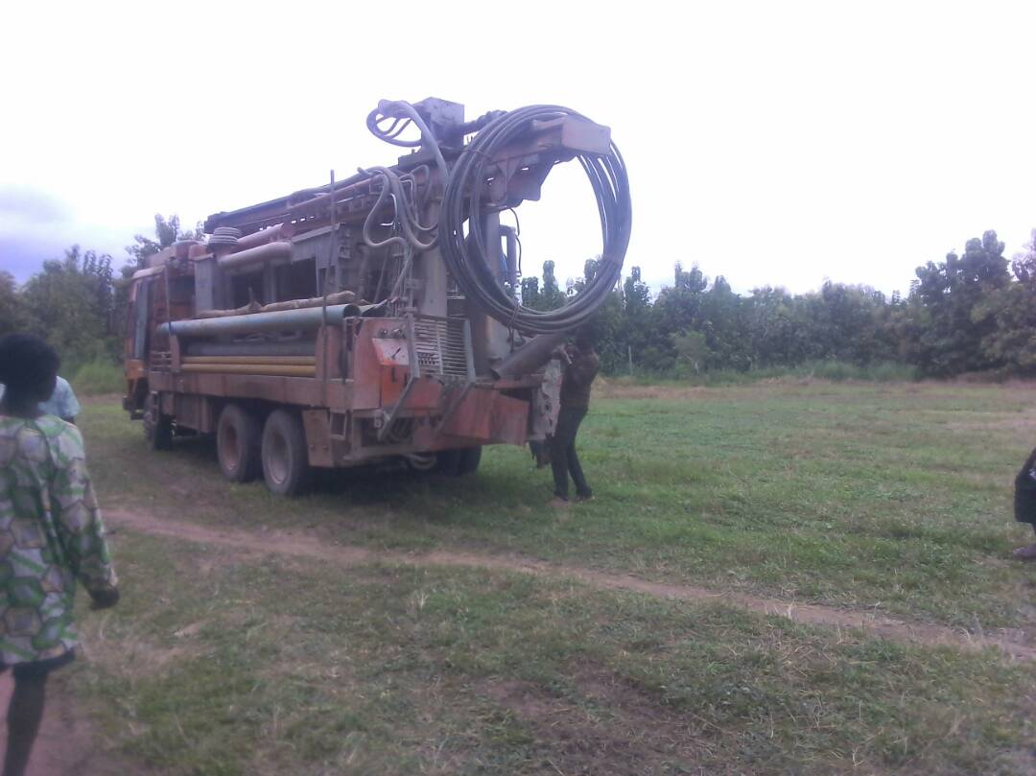

Fig.3- Conveying of digging truck 1 to the site

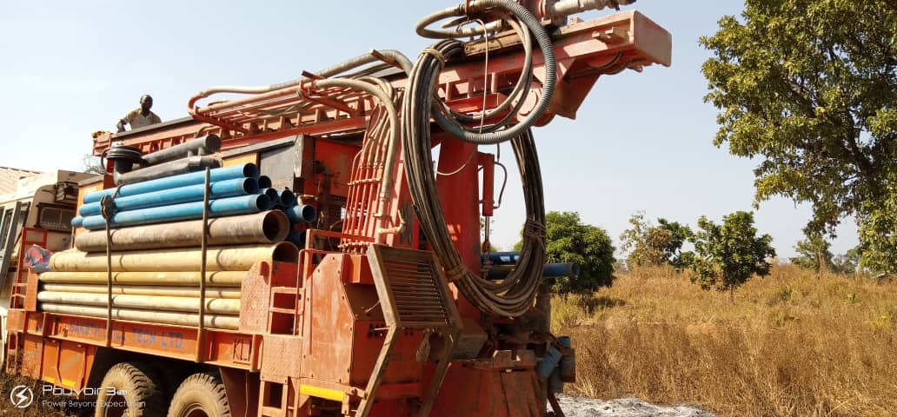

Fig.4- Conveying of digging truck 2 to the site

  - DIGGING OF WELL
A mechanical digging started on the 10th December 2019 as soon as the water bed was found. On the 13th December the water bed was reached and on the 15th December the water was drawn up.

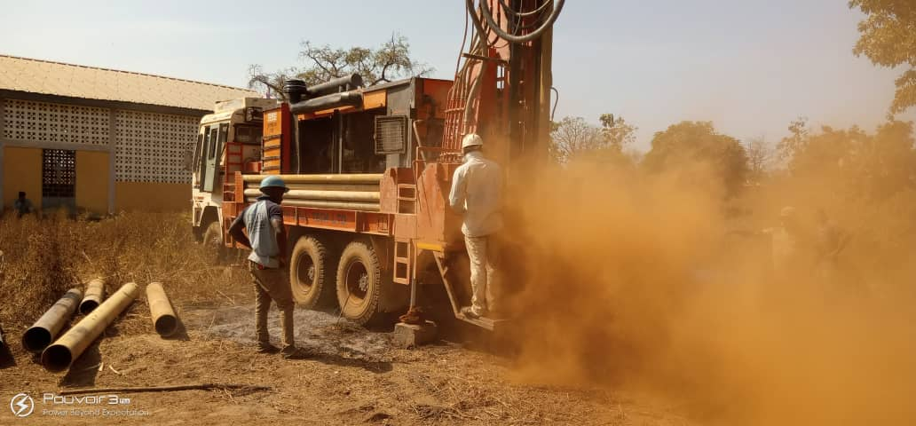

Fig. 5- Machine digging well, Phase 1

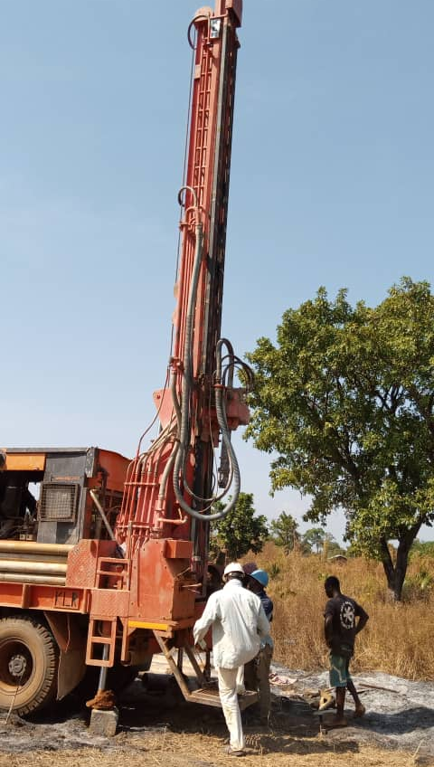

Fig. 6- Machine digging well, Phase 2

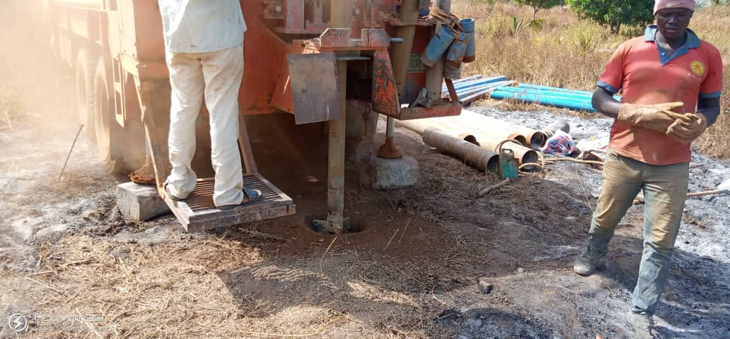

Fig. 7- Machine digging well, Phase 2

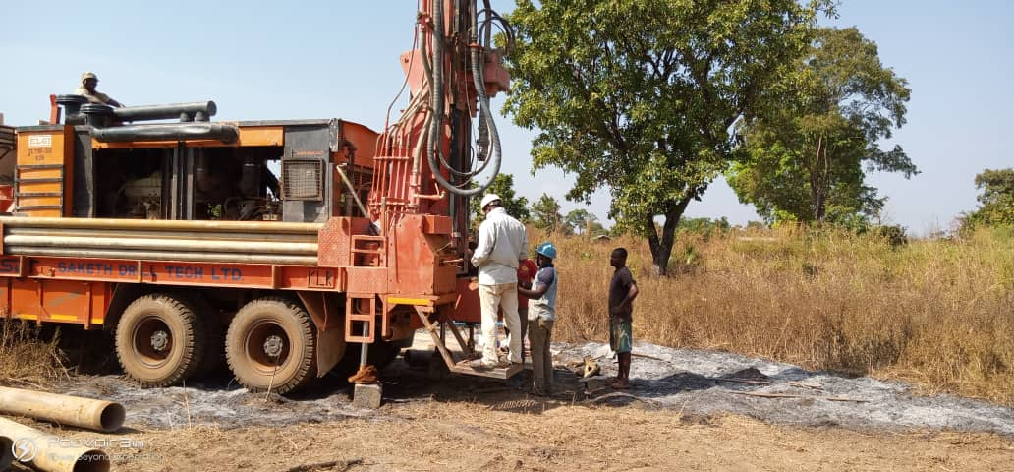

Fig. 8- Machine digging well, Phase 2

This was the most difficult part of the process but was done in a record of time due to the professionalism of the expert to which the work was assigned.
  - WALL BUILDING
There was a need to build a wall around the well to keep it clean, to maintain a hygienic standard and also to keep it out of reach of animal. A circular wall was then built around the well with a small opening with a metallic gate. This work took four days to be done from 11th to 15th December 2019.
- Fig. 9 – Fig. 12 – Wall building
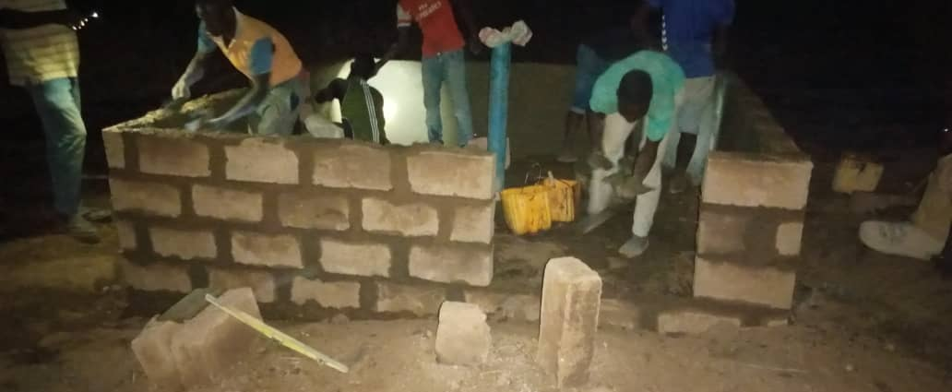
Fig. 9
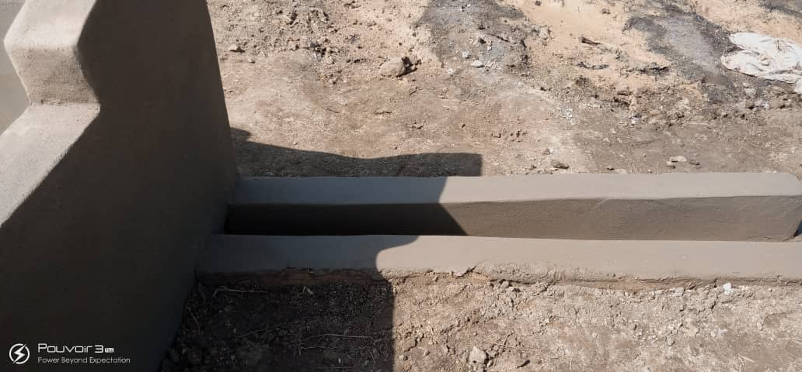
Fig. 10
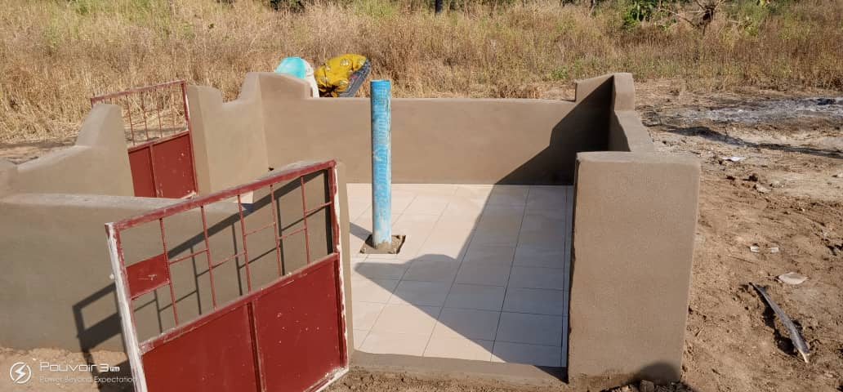
Fig.11
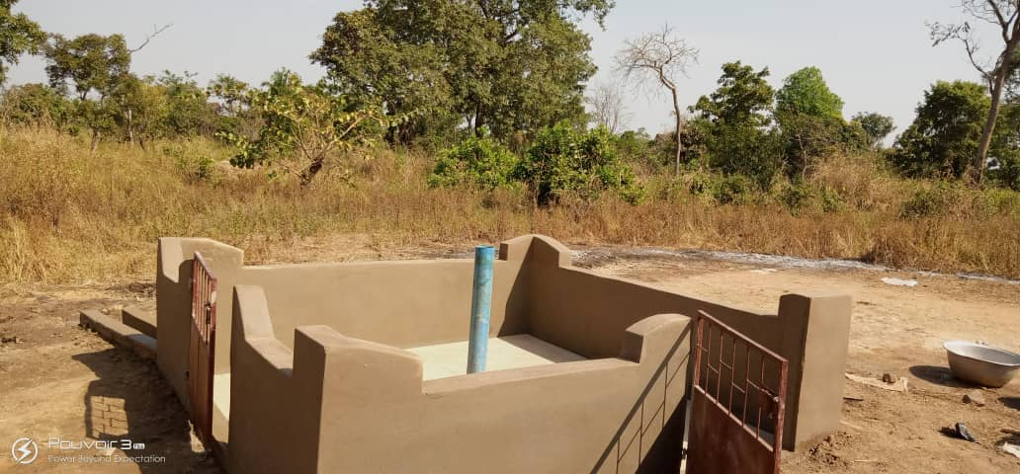
Fig. 12

  - BOREHOLE PUMP INSTALLATION
On the 16th of December 2019, the mechanic pump was installed. This was followed by pumping trials to draw up the water. This was done from 17th December 2019 to 6th January 2020 until clean water came out. It was then confirmed that the well was ready to be used.
- Fig. 13- Fig. 16- Pump installation and pumping trials.
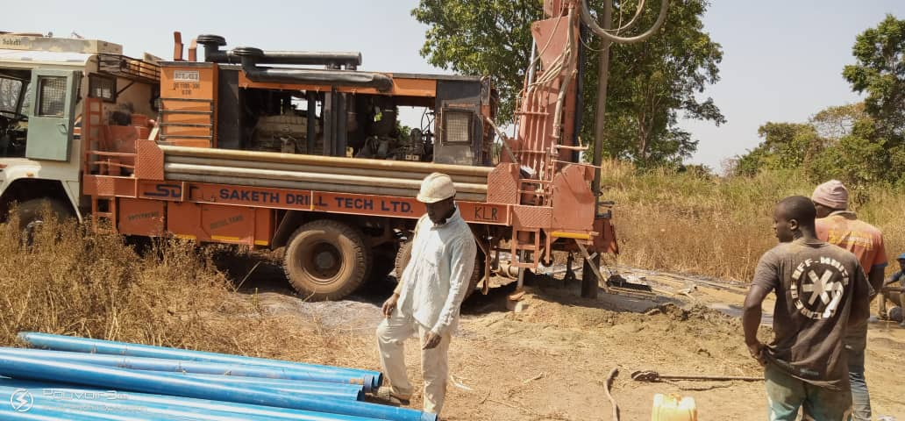
Fig. 13
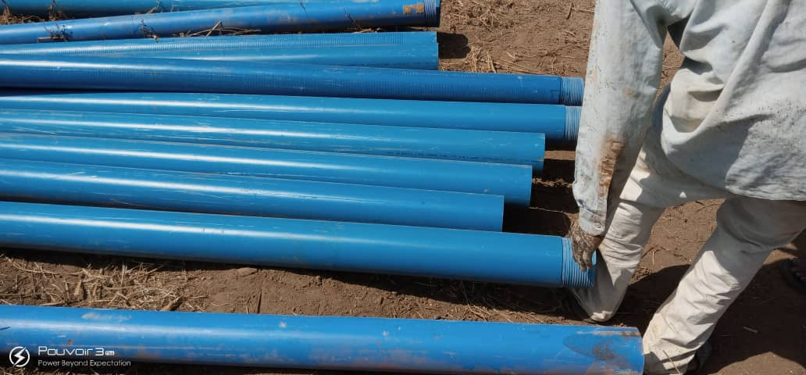
Fig. 14
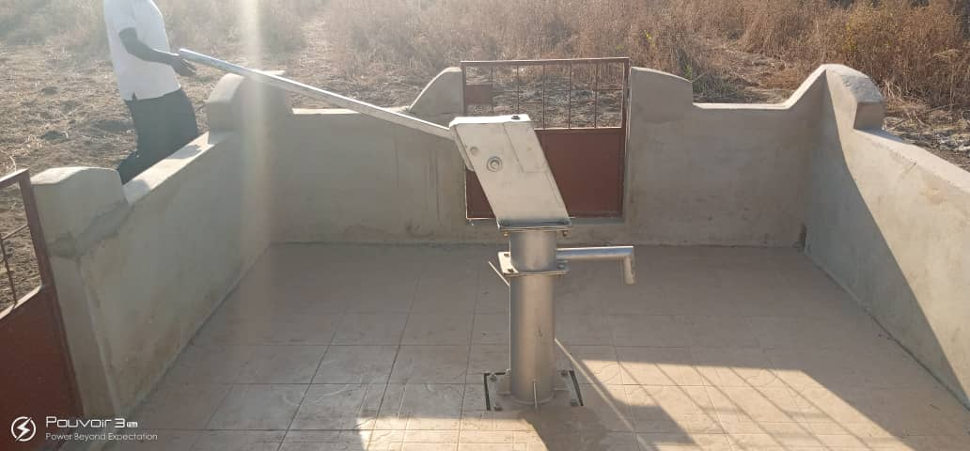
Fig. 15
Fig. 16
  - INAUGURATION
On the 10th January 2020, the team of SOMAGG lead by Fr. Odilon AMENYAGLO went to Samai -Affossalakopé for the inauguration of the well. They received a warming welcome from the villages with singing and dancing. There the team met Father Mathias, Pastor of Affossalakopé Parish and his assistance Fr Joel. The inauguration began with a thanksgiving mass during which the whole church prayed for the generous benefactors of Our Lady of Fatima Catholic Church especially for Jim and Ann-Marie BABISH. After this act of gratitude to God for giving us clean water through the generous benefactors a brief report was done by the team, they went ahead with a welcome address from the Chief of the village who expressed his gratitude for the gift of water which the longed for. Other villages too expressed their gratitude and narrated the sad cases of death due to the children walking several miles in the night or at dawn to fetch water and were bitten by snakes or instances where their women were denied access to water in the nearby village because of scarcity. The villages appreciated and cherish the gift of water. As a sign of gratitude, they offered some yams and a goat to the priests; especially to Fr Anicet who mediated for the project and was finally transferred.
After that the well was properly inaugurated by cutting of the ribbon, blessing of the fountain by Fr. Mathias and first water pumped out for villages to drink. This was followed by popular rejoicing and a concluding address from Fr. Odilon who explained to then how the project came about and where the donation came from.
It was a time of festivities and appreciation.
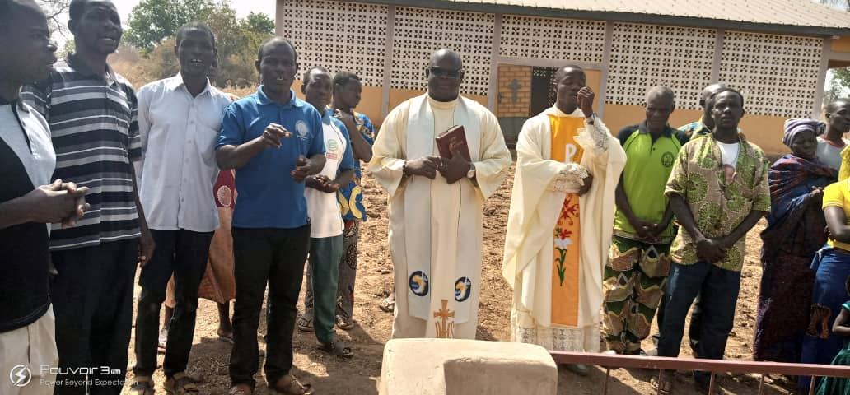

Fig. 17- A community leader addressing the people before the blessing
*
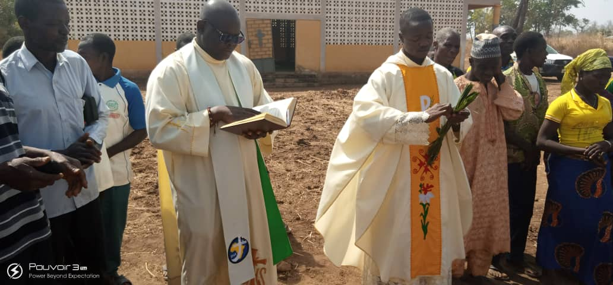

Fig. 18 – Fr. Mathias blessing the Well with Fr. Joel
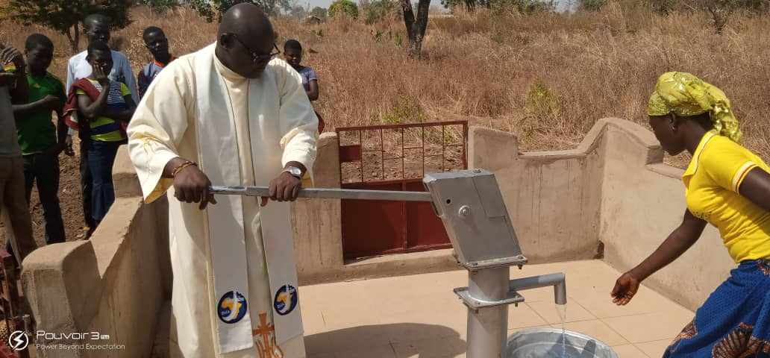

Fig. 19 – Fr. Mathias exercising some pumping
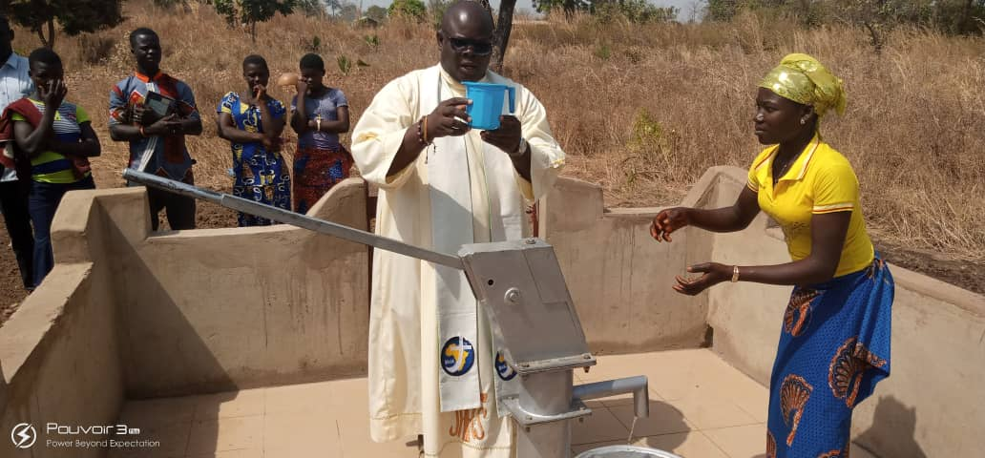
Fig. 20 – Fr. Mathias drinking water from the Well
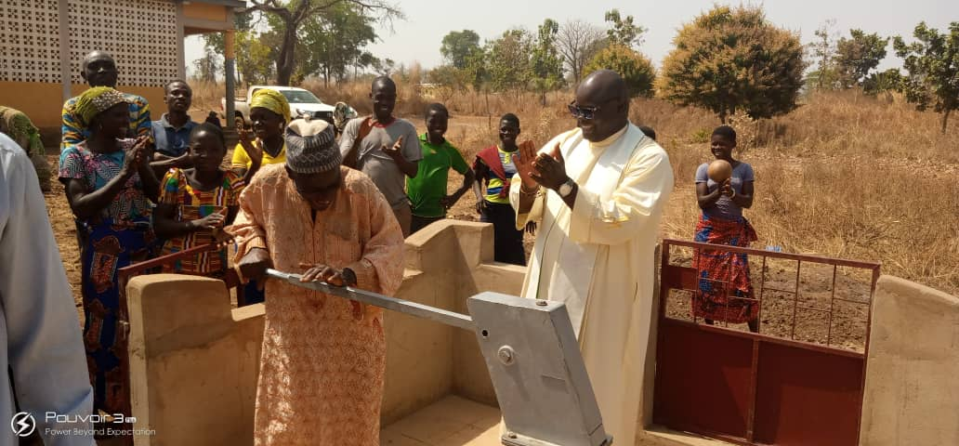

Fig. 21 – The chief of the community trying joyfully some pumping
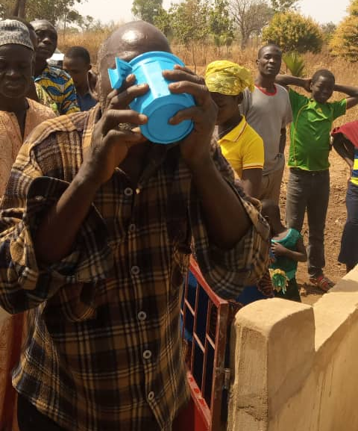

Fig. 22 – A member of the community drinking from the Well

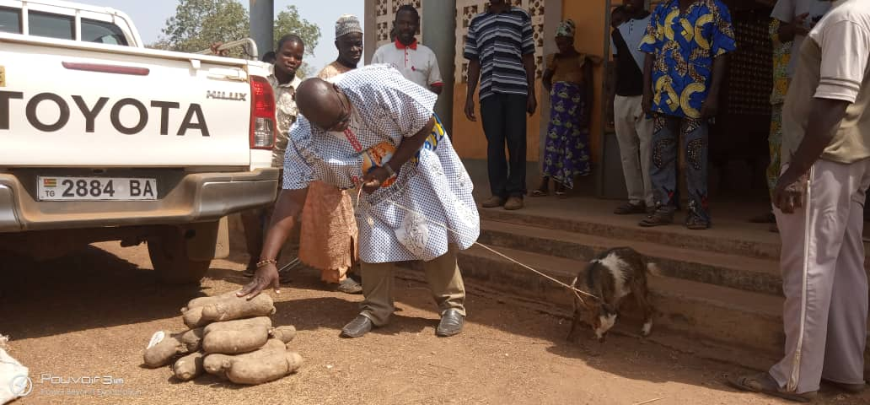

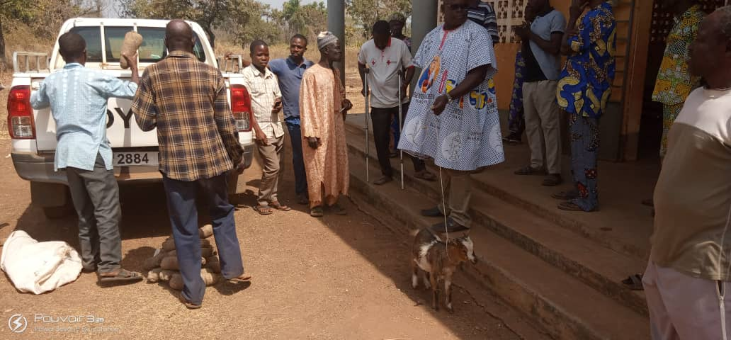

Fig. 23- Fr. Mathias receiving donation from the people of the community

- CONSTRAINTS

  - The month of November has been a raining season, the road was very bad rendering access to the site very difficult.

- CONCLUSION
The whole work was done by professionals making the whole project going according to the time frame allocated. The well was registered as part of the national well project so that its maintenance over long term will be made by the local government.

