PROJECT TITLE: Construction of a primary school for access to quality education for 300 children aged 5 to 12 in the suburb of Kpogan in Togo between 2019 and 2021.

Applicants: Sisters of Our Lady of the Apostles
P.O.Box: 4796 Lomé (TOGO)
Phone: (00228) 93 71 01 85
Mail: paulebit@yahoo.fr

Project Amount: 193.219.016 CFA or US 348,858.32
1 U.S. dollar - 553.86 on November 19th, 2020.

The aim of the project is to enable children of the suburb to have access to education in good conditions. The project stems from a request from the local community to have a school. This community is a suburb with a population that is primarily poor. Most of the inhabitants are into gardening because the area is sandy and not promoting crops growing, which is the most practiced activity in the country.
In addition to this precariousness, there are also numbers of problems our Togo educational system is facing. This is about the lack of school infrastructures, educational facilities, and so on. This lack of schools is causing a plethora of students’ enrollment, accompanied with a lack of qualified teachers. This is a barrier to a quality of teaching/learning.
The initiative envisages the construction of a primary school equipped to ensure the effectiveness of the courses for the completion of the elementary certificate. The structure will be situated at a strategic location to facilitate the influx of students who are often unable to reach the region’s already scarce schools. Children are otherwise forced to travel long distances (18.6 miles) each day, with possible risks involved.
The specific objectives:
- Create classrooms and an administrative block;
- Equip the structure with furniture and educational materials;
- Provide teachers with educational training;
- To raise awareness of the importance of children’s schooling.

Project activities:
- Construction of 6 classrooms, 6 toilets, 1 accounting room, 1 secretariat, 1 managerial room, 1 monitoring room, 1 small shop, 1 borehole.
- Making 150 learning tables/desks, 10 teacher and administrative staff desks, 12 chairs.
- Purchase of 300 textbooks, 20 teaching guides for teachers.
- Three workshop training held during the academical year, which implies one training every quarter with four sessions of two hours during the training.
- Raising awareness among the local population.

The results of the project:
- The 6 classrooms, the 6 toilets, the 4 rooms of the administrative block, the storage are built and the borehole drilled.
- The 150 learning tables/desks, the 10 teacher and administrative staff desks, the 12 chairs are made.
- The 300 textbooks and the 20 teaching guides are purchased.
- The three training workshops are done.
- Awareness among the targeted population is made.

This project is accepted by the EPISCOPAL CONFERENCE OF ITALIA to whom we say a sincere thank you. The first installment is already granted and the work completed to that level. There is still the last installment to be granted to complete the project as a whole.

QUELQUES IMAGES DE LA REALISATION EN COURS

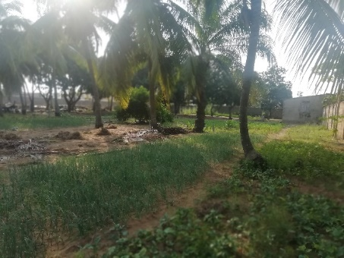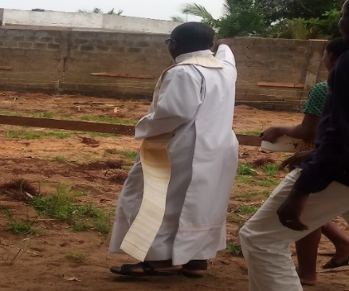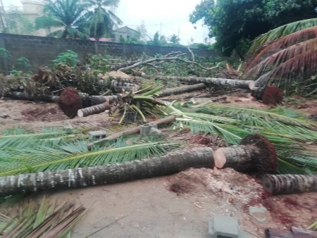Terrain nu Bénédiction du cite Aménagement du cite

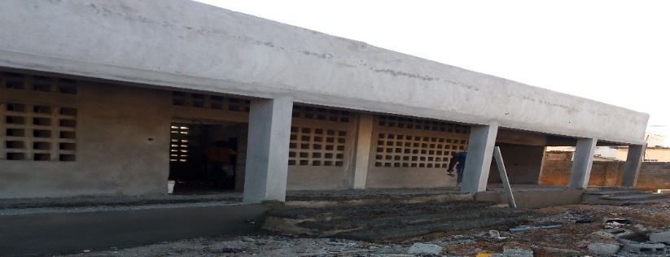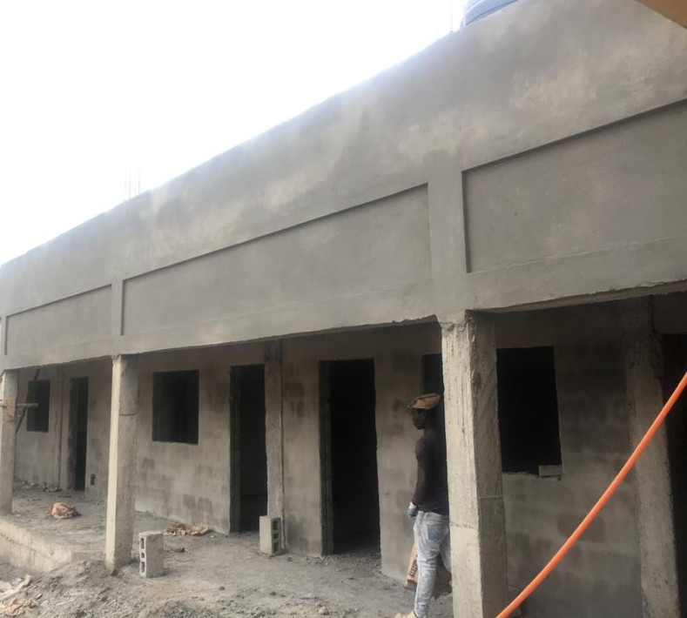
Les salles de classe niveau crépissage le bloc administratif en crépissage

Le magasin

