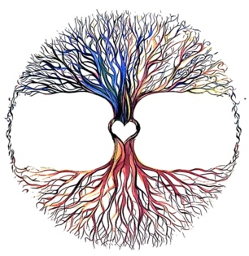  Blood Sugar Logs |  |  | For the Love of Health  412 Gray Street Dowagiac MI. 49047  269-462-9258 Fax: 269-215-6248  www.fortheloveofhealth.com
Date | Morning | Afternoon | Evening | Bedtime

