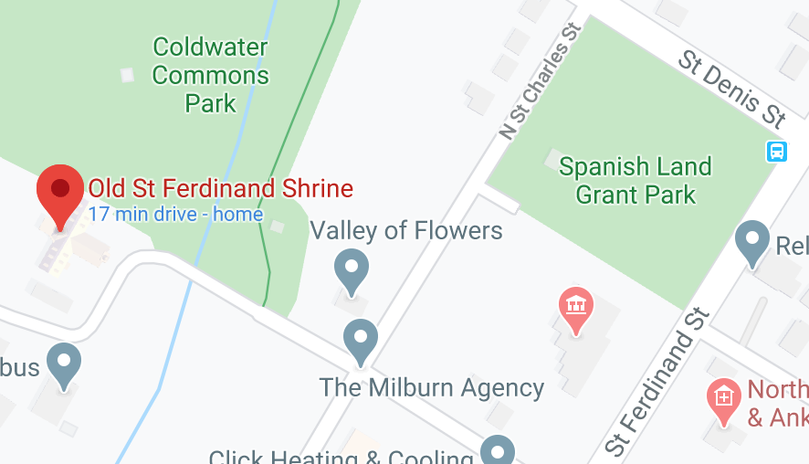
Rue St. Francois
X

From North: Hwy 67 (Lindbergh) south, left on St. Ferdinand St, right on Rue St. Francois 1-1/2 blocks. From South: I-270 East or West to north on Lindbergh, right on Washington St., left on St. Charles St. Free parking on the street. The gazebo (see the Red X on the map above) is on the north side of Rue St. Francois in Coldwater Commons Park.

VALLEY OF THE FLOWERS
FESTIVAL WALK
Jackie Burgoon Memorial Walk
Saturday, May 8, 2021
Gazebo on the grounds of the Old St. Ferdinand Shrine
Florissant, St. Louis County, Missouri

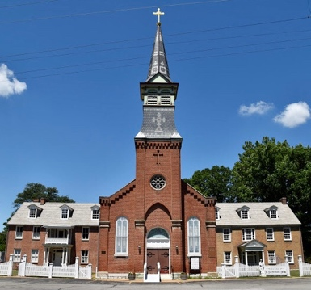
Walk Rating: 1A
EVENT ID: 118766
SPONSORED BY: Saint Louis Walkers

Special Programs:
Little Free Libraries
Rockin’ Around the Clock
Walking the USA A-Z
Walking with America’s Veterans

Because of Covid restrictions, there is no festival this year. Our new route goes through Old Town Florissant with its many historic French-style homes, including the oldest home in Florissant, the Shrine, Florissant City Hall, and several Florissant parks.
START LOCATION: The gazebo in Coldwater Commons Park, just north of Rue St. Francois, across from the grassy field, to the right side of Old St. Ferdinand Shrine as you face it.

PARKING: Free parking on the street

TIME: Register 9 – 11 am. This event will take place regardless of weather.

ACCOMMODATIONS: Because there is no festival this year, there are no porta-potties at the Start. Please use a restroom before arrival. The route goes past Dierberg’s and park restrooms.

DISTANCE: 5k and 10k routes have detailed directions and maps. The routes may be difficult for strollers or wheelchairs because there are some gentle hills.

POC: Donna and Charlie Dasho, donawbr@aol.com, 314-831-0726

REGISTRATION: Fee is $3 for each walker. Event is open to all.

REFRESHMENTS: Water is available at the gazebo.

PETS: Leashed pets are allowed on the walk but not inside buildings. Please clean up after your pet and bring fresh water for it.

PROCEDURE: To register, get a Start card and fill it out and turn it in. $3/walker.
WEB SITES:
www.ava.org or www.saintlouiswalkers.com

DISCLAIMER:
AVA and the Saint Louis Walkers are not liable for accidents, thefts, and/or material damage. Every effort will be made by the sponsors to make this event safe and enjoyable.

We hope you enjoy the Valley of the Flowers Festival Walk!

Sanction: Sanctioned by the American Volkssport Association (AVA), a member of the International Federation of Popular Sports (IVV). This event counts toward the acquisition of IVV Achievement Awards. Bring both IVV books (event and distance). IVV books are available at the start/finish for $6.00 each. There will be no Awards or pins.

